FIB-SEM data processing and stack registration using SIFT

*G.Shtengel*

Table of Contents

FIB-SEM data processing and stack registration using SIFT 1

1 Introduction: 2

1.1 General Registration Workflow 2

1.2 Determining the Transformation Coefficients from Key Point pairs 3

1.3 Regularization of the Affine Transformation: Ridge Regression 4

1.4 Note on Data Padding 4

1.5 Evaluation of the registration quality 5

2 Python notebook code locations and Python environment requirements 6

3 Running the Python Notebook 7

3.1 Start the Python Notebook. 7

3.2 Step 0: Set up the processing parameters. Check the data and evaluate the Threshold parameters. 7

3.2.1 Make sure the thresholds (thr_min and thr_max) and kp_max_num parameters are set properly. 7

3.2.2 Setting other parameters 8

3.3 Step 1: Set up Local DASK Client and Monitor Window. 11

3.4 Step 2: Calculate the Global Data Range. 12

3.5 Steps 3 and 4: Extract Key Points and Descriptors, Find Matches and Transformations. 13

3.6 Step 5: Search for frames with no (or low# of) matches and possibly remove them. 13

3.7 Step 6: Recall or Save the Intermediate Data (Key Points, Matches, Transf. Matrix, etc.) from / into spreadsheets and binary files. Remove the intermediate Key Point/Descriptor files. 14

3.8 Step 7. Transform frames (convert to I8 if desired), bin x2 in Z direction if desired, and save into a registered MRC stack. 14

4 Results and Discussion 14

5 Appendix 2. FIB-SEM data frame readout and processing 35

6 Appendix 2. Details on the implementation steps in the process of FIB-SEM stack registration using SIFT 37

6.1 Extract Keypoints and descriptors for each frame. 37

6.2 Packaging / Unpackaging Key Points. 37

6.3 Find Key Point matches and determining the Transformation Matrices for each consecutive pair of FIB-SEM frames. 38

6.4 Implementation of Regularized Affine Transformation 38

7 Appendix 3: Optimization of parameters used during SIFT Key Point discovery and matching. 40

7.1 Choosing optimal thresholds. 40

8 References 41

# Introduction:

## General Registration Workflow

The FIB-SEM stack may have small shifts and scale changes between subsequent frames. Registration is performed in these main steps:

* SIFT algorithm (Scale Invariant Feature Transform) (*1*) is used to identify the Key Points in every frame.
* Key Points in the subsequent frames are matched using FLANN (Fast Library for Approximate Nearest Neighbors) or BF (Brute Force) matchers.
* Transformation matrix is determined for a given model (Shift only, Shift and Scale, unconstrained Affine, or Regularized Affine) using either RANSAC (Random Sample Consensus) algorithm, or iterative Linear Regression with throwing worst outliers heuristics. See Section 1.2 for details.

Transformation matrix (registering the *j-th* frame to *j-1-th* frame) is determined in the following format:

$M^{j}=\left(\begin{matrix}S_{xx}^{j} & S_{xy}^{j} & T_{x}^{j} \\ S_{yx}^{j} & S_{yy}^{j} & T_{y}^{j} \\ 0 & 0 & 1\end{matrix}\right)$, or $S^{j}=\left(\begin{matrix}S_{xx}^{j} & S_{xy}^{j} \\ S_{yx}^{j} & S_{yy}^{j}\end{matrix}\right)$ and $T^{j}=\left(\begin{matrix}T_{x}^{j} \\ T_{y}^{j}\end{matrix}\right)$ (1),

where $S_{xx}$ and $S_{yy}$ are the scale terms, $S_{xy}$ and $S_{yx}$ the shear terms, and $T_{x}$ and $T_{y}$ the shift terms.

The coordinates of Key Points in *j-th* frame and *j-1-th* frame are related via:

${\left(\begin{matrix}x^{j} \\ y^{j} \\ 1\end{matrix}\right)= M}^{j}*\left(\begin{matrix}x^{j-1} \\ y^{j-1} \\ 1\end{matrix}\right)$ or ${\left(\begin{matrix}x^{j} \\ y^{j}\end{matrix}\right)= S}^{j}*\left(\begin{matrix}x^{j-1} \\ y^{j-1}\end{matrix}\right){+T}^{j}$ (2).

Frame 0 is treated as reference frame and is not transformed:

$M^{0}=\left(\begin{matrix}1 & 0 & 0 \\ 0 & 1 & 0 \\ 0 & 0 & 1\end{matrix}\right)$.

Parameters $S^{j}$ and $T^{j}$ for general transformation can be determined if sufficient number of correspondences (in most general case at least 8) have been established (*2*–*6*).

Once the transformation matrix for every frame pair has been determined, the cumulative transformation matrix for each frame is determined by cumulative matrix multiplication:

${CM}^{j}= {\left(\begin{matrix}{CS}_{xx}^{j} & CS_{xy}^{j} & {CT}_{x}^{j} \\ {CS}_{yx}^{j} & CS_{yy}^{j} & {CT}_{y}^{j} \\ 0 & 0 & 1\end{matrix}\right)=M}^{j}*M^{j-1}*…*M^{1}$ (3).

It turns out that the Scale and Affine transformations tend to accumulate scales and shears that (while minimizing the error) distort the images. Various patches have been proposed to address this problem, for example AMST(*7*). We use a simple approach – we subtract linear or non-linear trend fits of each individual cumulative transformation matrix element so that average cumulative scale terms ${CS}_{xx}$ and ${CS}_{yy}$ are equal to 1, and average cumulative shear terms ${CS}_{xy}$ and $CS_{yx}$ are equal to 0. This is illustrated in Figure 6. This seems to work well even for data sets with large jumps in scale (such as some J10 data sets).

## Determining the Transformation Coefficients from Key Point pairs

Once matched pairs of Key Point have been established the transformation matrix can be determined. Below is a list of considered transformations.

|  |  |  |
| --- | --- | --- |
| Transformation Model | Matrix | Parameter Estimation Algorithm |
| Translation (Rigid Shift) | $$\left(\begin{matrix}1 & 0 & T_{x} \\ 0 & 1 & T_{y} \\ 0 & 0 & 1\end{matrix}\right)$$ | $$\left(\begin{matrix}T_{x}^{j} \\ T_{y}^{j}\end{matrix}\right)=〈\left(\begin{matrix}x^{j} \\ y^{j}\end{matrix}\right)〉-〈 \left(\begin{matrix}x^{j-1} \\ y^{j-1}\end{matrix}\right)〉$$ |
| Scale and Translation | $$\left(\begin{matrix}S & 0 & T_{x} \\ 0 & S & T_{y} \\ 0 & 0 & 1\end{matrix}\right)$$ | Least squares regression (*2*–*4*) |
| Similarity | $$\left(\begin{matrix}S∙cos⁡\left(θ\right) & -S∙sin⁡\left(θ\right) & T_{x} \\ S∙sin⁡\left(θ\right) & S∙cos⁡\left(θ\right) & T_{y} \\ 0 & 0 & 1\end{matrix}\right)$$ | Least squares regression (*2*–*4*) |
| Unconstrained Affine | $$\left(\begin{matrix}S_{xx} & S_{xy} & T_{x} \\ S_{yx} & S_{yy} & T_{y} \\ 0 & 0 & 1\end{matrix}\right)$$ | Least squares regression (*5*) and Eq (6) below. |
| Regularized Affine | $\left(\begin{matrix}S_{xx} & S_{xy} & T_{x} \\ S_{yx} & S_{yy} & T_{y} \\ 0 & 0 & 1\end{matrix}\right)$ with target/penalty | Least squares regression with regularization (*6*) and Eqs. (9) and (11) in Section 1.3. |

Key Point pairs define the transformation via a system of linear equations which can be re-written as:

$\left(\begin{matrix}x_{1} & y_{1} & 1 & 0 & 0 & 0 \\ … & … & … & … & … & … \\ x_{n} & y_{n} & 1 & 0 & 0 & 0 \\ 0 & 0 & 0 & x_{1} & y_{1} & 1 \\ … & … & … & … & … & … \\ 0 & 0 & 0 & x_{n} & y_{n} & 1\end{matrix}\right)\left(\begin{matrix}S_{xx} \\ S_{xy} \\ T_{x} \\ S_{yx} \\ S_{yy} \\ T_{y}\end{matrix}\right)=\left(\begin{matrix}{\hat{x}}_{1} \\ … \\ {\hat{x}}_{n} \\ {\hat{y}}_{1} \\ … \\ {\hat{y}}_{n}\end{matrix}\right)$ (4),

where $\left(\begin{matrix}x_{i} \\ y_{i}\end{matrix}\right)$ and $\left(\begin{matrix}{\hat{x}}_{i} \\ {\hat{y}}_{i}\end{matrix}\right)$ are, respectively, the sets corresponding Key Points in source (moving) and destination (fixed) images. The Eq. (4) is often written in a matrix form as (bold font denotes matrices):

$Aθ= b$ (5).

In the case of most general affine transformation, if the number of key-points is larger than 6, the system of equations (4) or (5) is over-constrained and the exact solution does not exist. However, the value of $\hat{θ}$ determined as:

$\hat{θ}= {\left(A^{T}A\right)}^{-1}A^{T}b$ (6)

is known to provide a solution minimizing the ***L2*** norm (*5*) in the least squares sense:

$\hat{θ}= \underset{θ}{argmin}\left({\left\|Aθ-b\right\|}_{2}^{2}\right)$ (7).

Eq. (6) with some conditioning tricks is usually used to determine the coefficients of the general affine transformation from known sets of paired Key Points, slightly modified approaches are used for similarity transformations (*2*–*4*).

## Regularization of the Affine Transformation: Ridge Regression

In some cases, when the data is noisy, it may be advantageous to find a biased solution to the system of equations (4) or (5). A well-known approach is ridge regression (also known as Tikhonov regularization), which aims to minimize a modified ***L2*** norm:

$\hat{θ_{r}}= \underset{θ}{argmin}\left({\left\|Aθ-b\right\|}_{2}^{2}+ {\left\|Γθ\right\|}_{2}^{2}\right)$ (8).

A solution in this case is given by the following formula:

$\hat{θ_{r}}= {\left(A^{T}A+Γ^{T}Γ\right)}^{-1}A^{T}b= {\left(A^{T}A+λI\right)}^{-1}A^{T}b$ (9).

(There exists another regularization approach, known as LASSO (Least Absolute Shrinkage and Selection Operator), which similar, but uses ***L1*** norm instead of ***L2*** norm (*8*). LASSO regularization tends to minimize the number of parameters as well as their deviation from zero – this approach is more applicable to sparse sensing applications.)

In some cases, the different regularization is desirable, where not the solution norm ${\left\|Γθ\right\|}_{2}^{2}$ is to be minimized, but rather a deviation of the solution from a certain target solution is to be minimized. For example, we may want to look for solution close to a rigid translation, where we do not want to minimize the scales $S_{xx}$ and $S_{yy}$, but look for a solution with $S_{xx}$ and $S_{yy}$ terms as close to unity as possible. In such cases the minimization condition is:

$\hat{θ_{r}}= \underset{θ}{argmin}\left({\left\|Aθ-b\right\|}_{2}^{2}+ {\left\|Γ\left(θ-θ_{targ}\right)\right\|}_{2}^{2}\right)$ (10).

Solving Eq.(10) yields:

$\hat{θ_{r}}= {\left(A^{T}A+Γ^{T}Γ\right)}^{-1}\left(A^{T}b+Γ^{T}Γθ_{targ}\right)$ (11).

In the extreme cases Eq. (11) simplifies:

* setting $θ_{targ}=0$ reduces Eq. (11) to Eq. (9)
* setting $θ_{targ}=0$ and $Γ=0$ reduces Eq. (11) to Eq. (6)
* setting $Γ=∞$ reduces Eq. (11) to $\hat{θ_{r}}= θ_{targ}$.

In the case when the target transformation in the Eqs. (10, 11) is a rigid translation discussed above, the target solution is:

$θ_{targ.translation}=\left(\begin{matrix}1 & 0 & T_{x} & 0 & 1 & T_{y}\end{matrix}\right)$ (12).

Finally, if we do not want the translation terms $T_{x}$ and $T_{y}$ to be regularized, the corresponding terms in the regularization matrix can be set to 0:

$Γ_{targ.translation}=\left(\begin{matrix}λ & 0 & 0 & 0 & 0 & 0 \\ 0 & λ & 0 & 0 & 0 & 0 \\ 0 & 0 & 0 & 0 & 0 & 0 \\ 0 & 0 & 0 & λ & 0 & 0 \\ 0 & 0 & 0 & 0 & λ & 0 \\ 0 & 0 & 0 & 0 & 0 & 0\end{matrix}\right)$ (13).

Varying $λ$ between 0 and $∞$ within the ridge regression model described by Eqs. (11-13) should provide a continuum of solutions between the rigid translation and a full affine transformation (*9*).

## Note on Data Padding

Transformation may result in some data (potentially useful) being transformed out of the frame boundary, as shown in Figure 1. In order to avoid this, the original data needs to be padded. From the point of view of the transformation properties, the padding is equivalent to a simple shift:

$A=\left(\begin{matrix}1 & 0 & Ax \\ 0 & 1 & Ay \\ 0 & 0 & 1\end{matrix}\right)$.

This must be taken into account, and the transformation matrix for padded data is related to the original transformation matrix:

$M_{padded}=A*M_{original}*A^{-1}$.

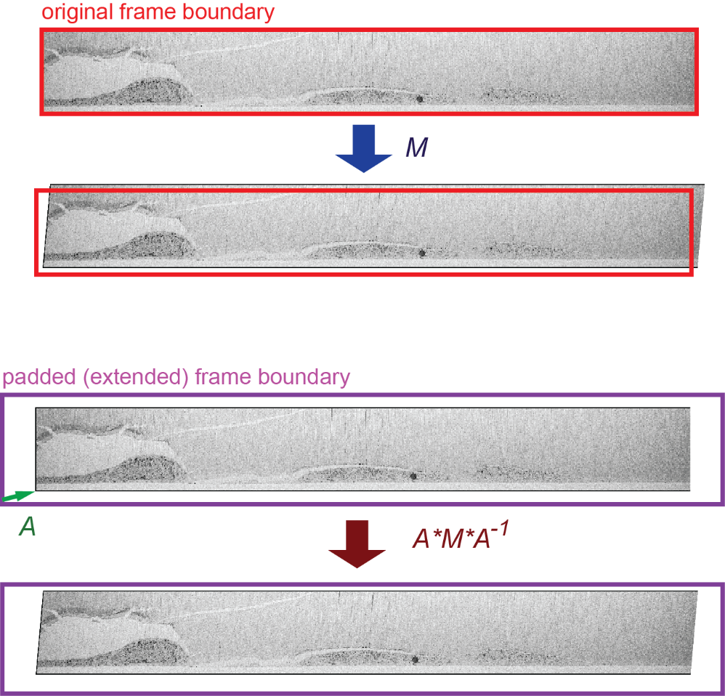

Figure . Padding the data and its effect on transformation matrix.

## Evaluation of the registration quality

Estimation of accuracy of registration algorithms is an important part of registration process. There are multiple ways to estimate the quality of the frame-to-frame registration based on the assumption that sequential frames *I1* and *I2* are expected to have statistically “similar” pixel values. The commonly used similarity measures are:

* Normalized Sum of Squared Difference (NSSD) (*10*) for two images *I1* and *I2* is defined as:

$NSSD\left(I1, I2\right)= \frac{1}{N}\sum_{i=1}^{N}{{\left({I1}_{i}-{I2}_{i}\right)}^{2}}$ (14),

* Normalized Sum of Absolute Difference (NSAD, also known as Image Delta) (*11*) uses ***L1*** norm instead of ***L2***:

$NSAD\left(I1, I2\right)= \frac{1}{N}\sum_{i=1}^{N}{\left|{I1}_{i}-{I2}_{i}\right|}$ (15),

* Normalized Cross-Correlation (NCC) between images *I1* and *I2* (*12*) is defined as:

$NCC\left(I1, I2\right)= N\frac{\sum_{i=1}^{N}{\left({I1}_{i}-〈I1〉\right)∙\left({I2}_{i}-〈I2〉\right)}}{\sum_{i=1}^{N}{{\left({I1}_{i}-〈I1〉\right)}^{2}∙}\sum_{i=1}^{N}{{\left({I2}_{i}-〈I2〉\right)}^{2}}}$, (16),

* Mutual Information (also sometimes called Normalized Mutual Information - NMI) defined in termes of entropies (*13*):

$MI\left(I1, I2\right)=H_{e}\left(I1\right)-H_{e}\left(I1 | I2\right)=H_{e}\left(I1\right)+H_{e}\left(I1\right)-H_{e}\left(I1, I2\right)$ (16), where the entropy $H_{e}\left(I1\right)$ of the variable $I1$ with probability density $p\left(I1\right)$ is:

$H_{e}\left(I1\right)=-\sum_{i=1}^{N}{p_{I1}\left({I1}_{i}\right)∙log\left(p_{I1}\left({I1}_{i}\right)\right)}$ (17), and $H_{e}\left(I1, I2\right)$ is a joint entropy:

$H_{e}\left(I1, I2\right)=-\sum_{i=1}^{N}{\sum_{j=1}^{N}{p_{I1, I2}\left({I1}_{i},{I2}_{j}\right)∙log\left(p_{I1, I2}\left({I1}_{i},{I2}_{j}\right)\right)}}$ (18).

Eq. (16) can be re-written using Eqs. (17-18):

$MI\left(I1, I2\right)=\sum_{i=1}^{N}{\sum_{j=1}^{N}{p_{I1, I2}\left({I1}_{i},{I2}_{j}\right)∙log\left(\frac{p_{I1, I2}\left({I1}_{i},{I2}_{j}\right)}{p_{I1}\left({I1}_{i}\right)∙p_{ I2}\left({I2}_{j}\right)}\right)}}$ (19).

In general, NCC assumes a linear relationship between two images, while NMI may capture non-linear dependencies between two images (*14*).

The results of the evaluation of the quality of registration using various metrics with data set LID556 are shown in Figure 2. A good registration minimizes the NSAD (Image Delta) and maximizes NCC and MI. Another important measure is a “spread” of the values of these metrics, illustrated in MI plot in Figure 2. Such spread is a measure of consistency, so a consistently good registration will have a low spread. A simple way to evaluate such spread is to subtract the averaged value of metric from the metric itself and then take a standard deviation of that difference.

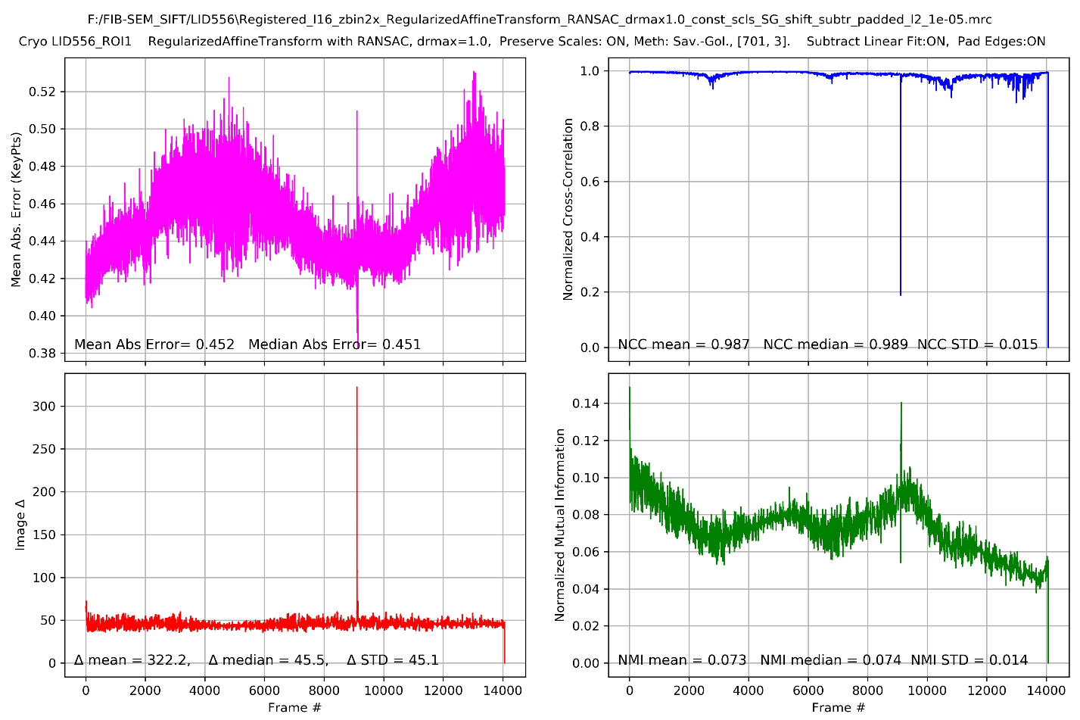

spread

Figure . Evaluation of the quality of registration using various metrics.

# Python notebook code locations and Python environment requirements

A “clean” notebook that can be used for FIB-SEM data processing and SIFT stack registration is located here:

\\dm11\hesslab\Python_Scripts\Register_FIB-SEM_stack_DASK_v0.ipynb

The notebook uses classes and functions defined in the file:

\\dm11\hesslab\FIB-SEM SIFT align code\Python code\SIFT_gs\FIBSEM_SIFT_gs.py

In order to run the Python notebook you need to copy the entire folder

\\dm11\hesslab\FIB-SEM SIFT align code\Python code\SIFT_gs\

Into the same directory as the notebook.

In order to run the Python Notebook code, first, install basic Anaconda:

<https://www.anaconda.com/products/individual>

This notebook uses OpenCV implementation of SIFT. SIFT is part of standard OpenCV releases for version 3.4.1 or earlier. If you have newer version of OpenCV-python installed, SIFT will most likely be not part of it (because of patent issues), and the Python command **sift = cv2.xfeatures2d.SIFT_create()** will generate error. In this case replace it with a version supporting SIFT using these commands (in anaconda command window):

Uninstall the OpenCV:

*>pip uninstall opencv-python*

Then install the contrib version of OpenCV:

>*pip install opencv-contrib-python*

You will also need to have these packages installed:

* mrcfile
* skimage
* dask
* pickle
* webbrowser
* IPython

# Running the Python Notebook

## Start the Python Notebook.

* Start Jupyter Notebook
* Execute two initial cells down to this:

**This is where the data processing begins**.

## Step 0: Set up the processing parameters. Check the data and evaluate the Threshold parameters.

* Make sure that **data_dir** point to the directory where the data is located.
* Also make sure that bad frames at the start of the run (coarse milling) are not included – or they will mess up the following calculations

### Make sure the thresholds (thr_min and thr_max) and kp_max_num parameters are set properly.

The next step is to make sure that the **threshold_min**, **threshold_max**, and **kp_max_num** parameters are set properly (they should be approximately **threshold_min**=3*10-5, **threshold_max**=1*10-4, and **kp_max_num**=10,000). See the Section 7.1 for more details on the **thr_min** and **thr_max** parameters. See the Figure 3 and text below it for more details.

### Setting other parameters

Set the parameter **BFmatcher=False**. There are two matchers, BF (Brute Force) and FLANN, with FLANN executing a little faster and also yielding more keypoints, see Section 6.3 and for more details. **BFmatcher=False** is recommended**.**

Set the parameter **SIFT_Transform**. The options are:

- **ShiftTransform** – rigid transfiormation with no rotation - only x-shift and y-shift are allowed.

**- XScaleShiftTransform** – x-scale, x-shift, and y-shift are allowed. No rotation.

**- ScaleShiftTransform** – x-scale, y-scale, x-shift, and y-shift are allowed. No rotation

**- AffineTransform** – full Affine (x-scale, y-scale, rotation, shear, x-shift, y-shift – all are allowed).

**SIFT_Transform = ShiftTransform** or **AffineTransform** is recommended **(still working on RegularizedAffineTransform).**

In the case of RegularizedAffineTransform, the regularization strength (shrinkage parameter, defined in Eq.(12)) and regularization target (defined in Eq. (11)) need to be set. The following block is used to do this:

***if SIFT_Transform == RegularizedAffineTransform:***

***l2_param = 1e-5 # regularization strength (shrinkage parameter).***

***l2_matrix = np.eye(6)*l2_param # initially set equal shrinkage on all coefficients***

***l2_matrix[2,2]=0 # turn OFF the regularization on shifts***

***l2_matrix[5,5]=0 # turn OFF the regularization on shifts***

***targ_targ_vector = np.array([1, 0, 0, 0, 1, 0]) # target transformation is shift only: Sxx=Syy=1, Sxy=Syx=0***

***…***

***else:***

***l2_matrix= None***

***targ_targ_vector = None***

Set **solver** parameter. The options are:

**solver = 'RANSAC'** – will use RANSAC (Random Sample Consensus) algorithm (*15*) for determining the best transformation matrix within the model defined above. RANSAC algorithm is usually used with SIFT for estimating homography of complex images (*16*, *17*), and we found it to work well for FIB-SEM frame matching as well.

**solver = 'LinReg'** – will use linear regression with iterative "Throwing out the Worst Residual" heuristic.

**solver = 'RANSAC'** is recommended.

Set the threshold parameter **drmax = 2** (dimensions – pixels).

In the case of **solver = 'RANSAC'** - Maximum distance for a data point to be classified as an inlier.

In the case of **solver = 'LinReg'**, this parameter outlier threshold for iterative regression. For each *i-th* matched pair of keypoins, the error is calculated as ${Error}_{i}=\left|{Dst.Point}_{i}-M*{Src.Point}_{i}\right|$. The iterative procedure throws away the matched keypoint pair with worst error on every iteration until the worst error falls below **drmax** or the max number of iterations is reached.

**drmax = 2** is recommended.

**max_iter = 100** - max number of iterations in the iterative procedures above.

**max_iter = 100** is recommended.

**save_asI8** = **True**. If this parameter is set to **True**, the data will be converted to I8 using global MIN and MAX values determined in the Step 2 (Section 3.2).

**preserve_scales = True**. If this parameter is set to **True**, the transformation matrix will be adjusted to keep the scales constant and shear to minimum.

**preserve_scales = True** is recommended.

**fit_params = ['LF']** - the above procedure will be done by subtracting linear fits (LF), so that average cumulative scale terms ${CS}_{xx}$ and ${CS}_{yy}$ are equal to 1, and cumulative shear terms ${CS}_{xy}$ and $CS_{yx}$ are equal to 0.

**fit_params = ['PF', 2]** - the above procedure will be done by subtracting polynomial fits (PF), second parameter is order, in this case 2 (quadratic fit).

**fit_params = ['SG', 701, 3]** - the above procedure will be done by subtracting the Savitzky-Golay (SG) fits with parameters window size 701, polynomial order 3.

**subtract_linear_fit** = **True**. If this parameter is set to **True**, the linear slope will be subtracted from the cumulative shifts. This is performed after the optimal frame-to-frame shifts are recalculated for **preserve_scales = True**.

**subtract_linear_fit** = **True** is recommended.

**pad_edges** = **True**. If this parameter is set to **True**, the edges will be padded with the amount equal to max shift excursion in each direction.

**pad_edges** = **True** is recommended.

**zbin_2x** = **True**. If this parameter is set to **True**, the data will be binned (averaged) x2 along z- (FIB-SEM milling) direction.

**int_order = 1** The order of interpolation performed by warp function (skimage package). The order has to be in the range 0-5:

- 0: Nearest-neighbor

- 1: Bi-linear (default)

- 2: Bi-

- 3: Bi-cubic

- 4: Bi-quartic

- 5: Bi-quintic

**int_order = 1** is recommended.

Executing this cell will produce the plots shown below (Figure 3). Ideally you would want to have at least 500 to 5000 Key Point matches for each pair of frames, but probably not much more than 10,000 matches – otherwise the calculation may become slow. We found that so far setting **threshold_min**=3*10-5, **threshold_max**=1*10-4, and **kp_max_num**= 10,000 works well.

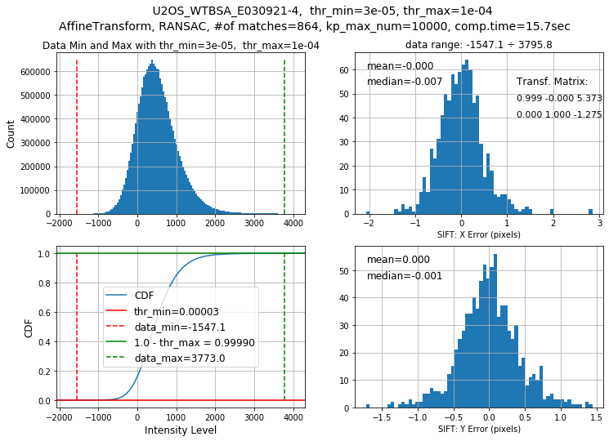

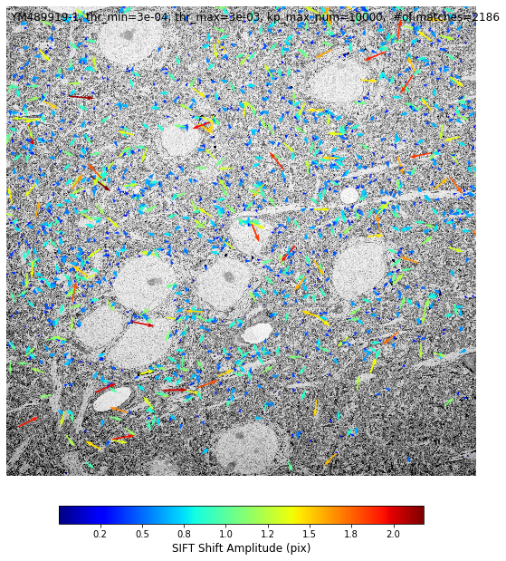

Figure . Figures produced by the notebook to help choosing the right value for the threshold parameter.

## Step 1: Set up Local DASK Client and Monitor Window.

Once the parameters have been set, proceed to the next cell to set up the DASK Client and Monitor Window. The progress can be monitored in the cell as shown in Figure 4.

Keep in mind that if you abort the execution of a cell that uses the DASK Distributed Client, you will need to re-start it (execute the cell under Step 1) to re-start these calculations.

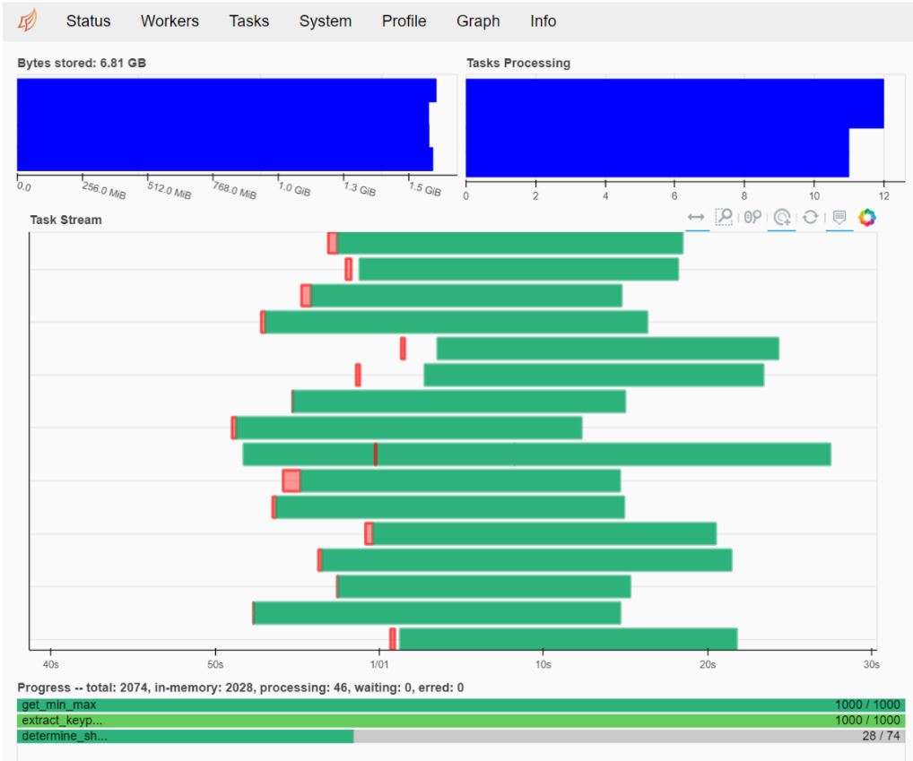

Figure 4. Result of the Step 1: Notebook cell showing SIFT computation progress on the local cluster.

## Step 2: Calculate the Global Data Range.

Execute the next cell. Once Step 1 is completed, the Data Minima and Maxima for each frame will be shown along with the set values of **data_min_glob** and **data_max_glob**, as shown in Figure 5. If the Maxima or Minima curves have sharp peaks at the beginning – make sure the data frames that were collected during coarse FIB-SEM milling have been removed, remove not, and then re-run the cells Step 1 and Step 2.

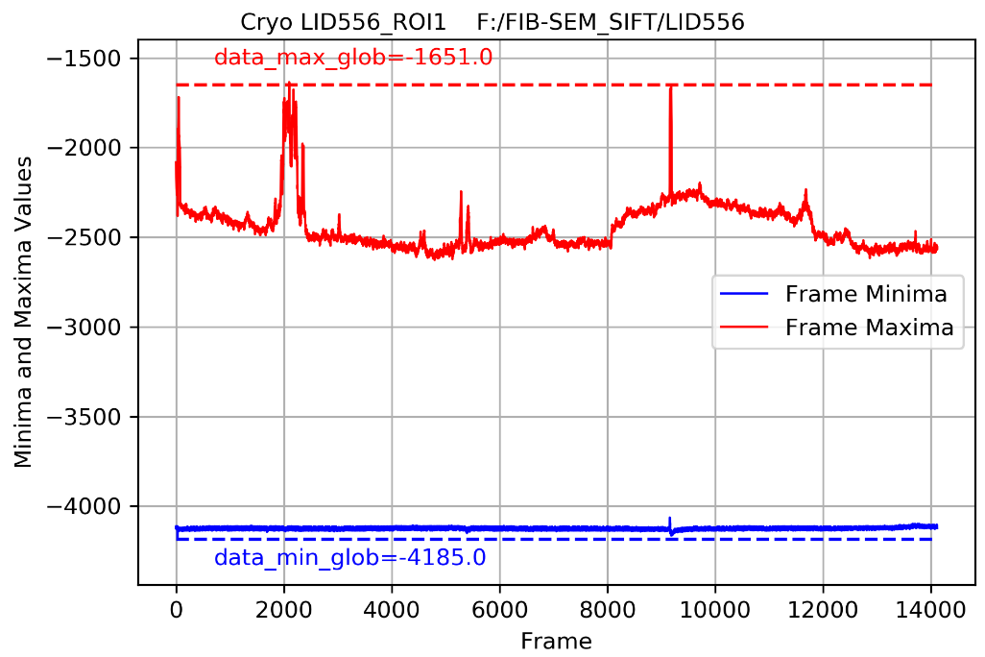

Figure 5. Result of the Step 2: Calculated Global Data Range.

## Steps 3 and 4: Extract Key Points and Descriptors, Find Matches and Transformations.

Execute the next cell. Once the transformations between consecutive frames are determined, the cumulative transformation matrix is calculated. See the results shown in Figure 6, they are a useful check on setting the parameters described above.

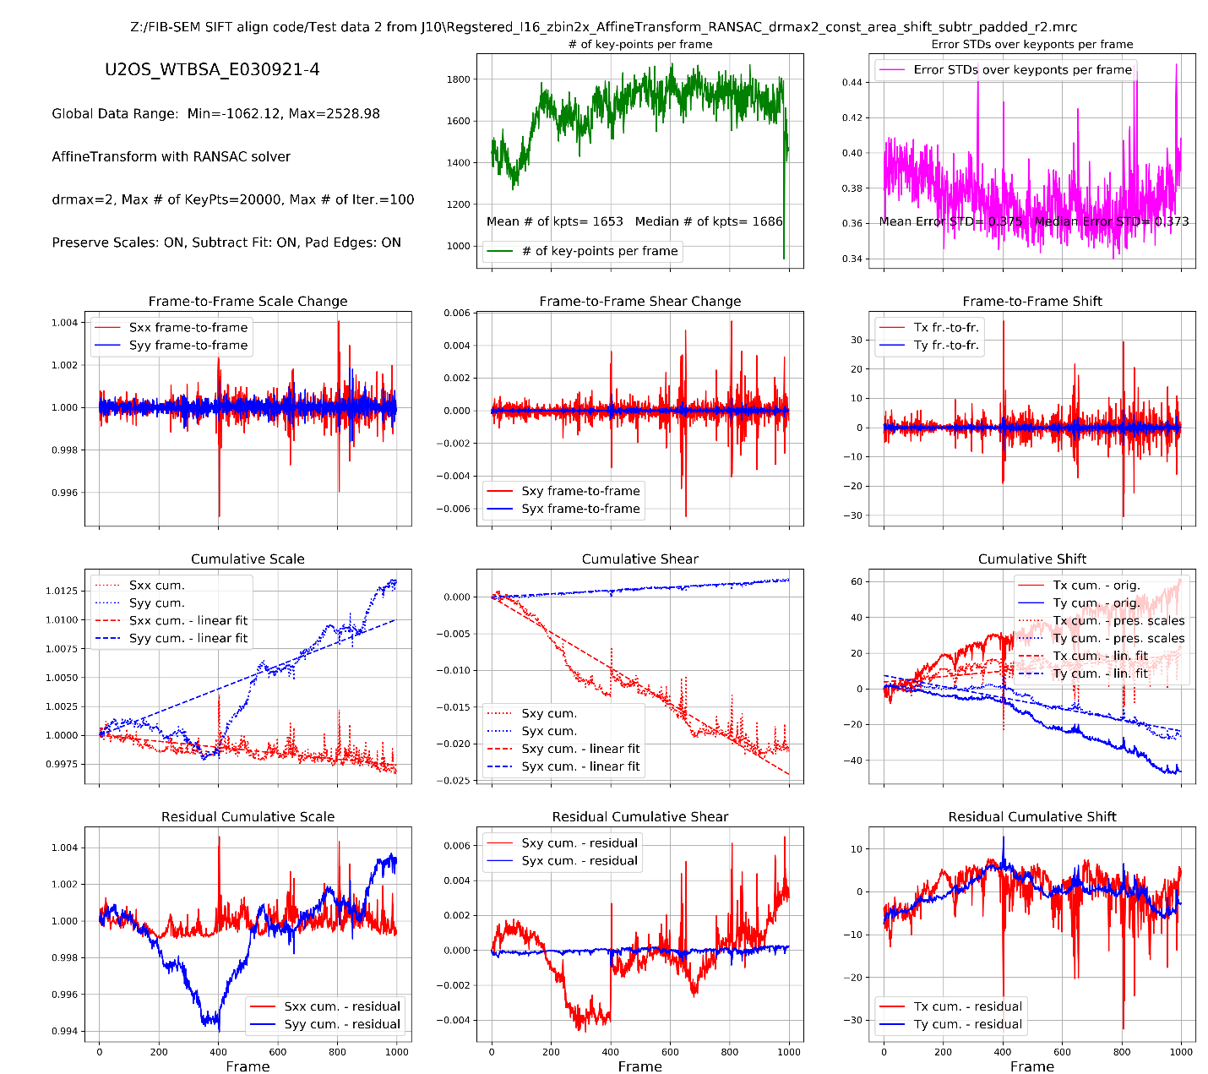

Figure 6. Results of the Steps 3 and 4: Transformation matrix parameters calculated for the data set “U2OS_WTBSA_E030921-4” with Affine transformation model and RANSAC solver. Numbers of Key Points for each consecutive pair of frames and the Error STD for Key Point matches are also shown (top row).

## Step 5: Search for frames with no (or low# of) matches and possibly remove them.

There is a possibility of a bad frame (very noisy or blank) saved during FIB-SEM acquisition. Such frame will most likely have no good Key Point matches with a frame before and frame after. We can use this to identify such bad frames and remove them from further consideration. In this case we would also need to calculate the transformations between the new neighbor frames.

Execute the next cell and it will detect instances of consecutive frames having less than 5 matched Key Points. The output will list all instances of these low-count matches and display snapshot images for these frames suggested for removal.

If agreed, proceed to the next cell and it will remove the suggested frames from the processing list and will calculate the transformations between new neighbors.

## Step 6: Recall or Save the Intermediate Data (Key Points, Matches, Transf. Matrix, etc.) from / into spreadsheets and binary files. Remove the intermediate Key Point/Descriptor files.

This cell allows to save the transformation matrix and all parameters in a binary format (as well as Excel files) for future analysis as well as debugging or re-starting the process. Set the **recall_the_data** to either **False** (default, data will be saved) or **True** (data will be re-called).

## Step 7. Transform frames (convert to I8 if desired), bin x2 in Z direction if desired, and save into a registered MRC stack.

The FIB-SEM data will now be transformed and saved. The following registration quality metrics will be calculated during this step for each pair of transformed sequential FIB-SEM frames: Normalized Sum of Absolute Difference (NSAD), Normalized Cross-Correlation (NCC), and Normalized Mutual Information (NMI). See Section 1.5 for the details. The results of these to estimates along with Error STDs (upper right panel in Figure 6) will be plotted once the data transformation and saving is completed, see Figure 2.

# Results and Discussion

We tested the code on few data sets with different samples and FIB-SEM conditions:

|  |  |  |
| --- | --- | --- |
| Data set | FIB-SEM imaging notes | Optimal Registration Model |
| U2OS_WTBSA_E030921-4 | Gemini450 - J10 data - with scale jumps | Unconstrained Affine or Regularized Affine with rigid shift as a target and λ= 10-7 ÷ 10-5 |
| U2OS_WTBSA_E030921-4 | Merlin-6284 - no scale jumps | Unconstrained Affine or Regularized Affine with rigid shift as a target and λ= 10-7 ÷ 10-5 |
| LID556 | 8nm, J3 – no scale jumps, but periods of very thin cells | Regularized Affine with rigid shift as a target and λ=10-5 |

Choice of the optimal transformation model and conditions depends on the data quality, sample geometry, and imaging conditions.

If the acquired data is known to have no significant scale jumps, Rigid Shift Only model works well.

If the acquired data has some scale jumps (some data sets acquired on J10 setup), this needs to be addressed, Affine Transformation does this. Using Full (unconstrained) Affine Transformation produces better registration even in the case where the scale jumps were not severe (see Figure 9, Table 3) but is particularly advantageous where there are big scale jumps (as can be observed on some J10 data – see Figure 8, Table 2). There is a noticeable improvement (particularly in the NCC spread) when switching from Shift-only rigid transformation to Scale+Shift transformation, and then further improvement when switching from Scale+Shift transformation to Full Affine transformation.

However, unconstrained Affine Transformation model may be prone to “overfitting”, especially in the cases of high aspect ratios and when the data has little content in y-direction (for example, when the cells are very flat/thin). When the areas (cells) that can have many Key Points are thin, the Affine Transformation may produce very noisy results (NSAD, NCC, and MI have high spreads). See the results for the data set LID556 in Figure 7 and Table 1. Rigid Shift Only transformation produces best values of NSAD, NCC, and MI, but the spreads are high.

Regularized Affine transformation mitigates this problem. The lowest values of spreads of NCC, and MI that can be obtained with Regularized Affine Transformation (with rigid shift transformation as a target and the regularization parameter λ=10-5) see Figure 7 and Table 1. Interestingly, rigid shift only transformation has high MI spread and low NCC spread, while full affine has lower MI spread and higher NCC spread. Regularized Affine Transformation with rigid shift transformation as a target and the regularization parameter λ=10-5 has both NCC and MI spreads close to lowest range for this data set.

In the case when the data had a reasonable aspect ratio and distribution of features, unconstrained Affine Transformation model performs well, but Regularized Affine Transformation with Rigid Shift as a target and λ=10-5 produces nearly identical result (see for example Figure 10 and Table 4).

Based on the data that we used for testing, it seems that the Regularized Affine Transformation with Rigid Shift as a target and λ=10-5 is an optimal “universal” model, that would work reliably with a wide range of samples.

* Normalized Cross-Correlation (NCC) seems to be more reliable metric than Normalized Sum of Absolute Differences (NSAD) – NCC does not vary with scaling so could be useful in comparing different data sets. Both the median value of NCC and it spread (STD) are important – ideally you want to have as high median value as possible and as little spread as possible.
* The average value of Mutual Information (MI) is not as clear to understand. The spread of MI seems to correlate with spread on NCC and spread of NSAD, but it is not a monotonous trend.
* It seems that the Python/Open CV workflow produces somewhat better registration than the FiJi workflow. We do not yet understand why (see comparisons in Figure 12and Figure 14).
* It seems that the bi-linear interpolation during transformations within Python/Open CV workflow produces significantly better registration than bi-cubic interpolation (see comparisons in Figure 13 and Figure 15). We do not yet understand why.
* Subtracting a trend to keep the scales constant and shear to minimum can be done using various fit method. Simplest linear fit produces (very) slightly better result (judging by Image Delta and NCC metric) than either quadratic fir or Savitsky-Golay Smoothing (see the data in Table 7 and Table 8). However, this is probably worth further explorations – may be the cell distortions are smaller under latter conditions even if at a small expense of NCC metric.

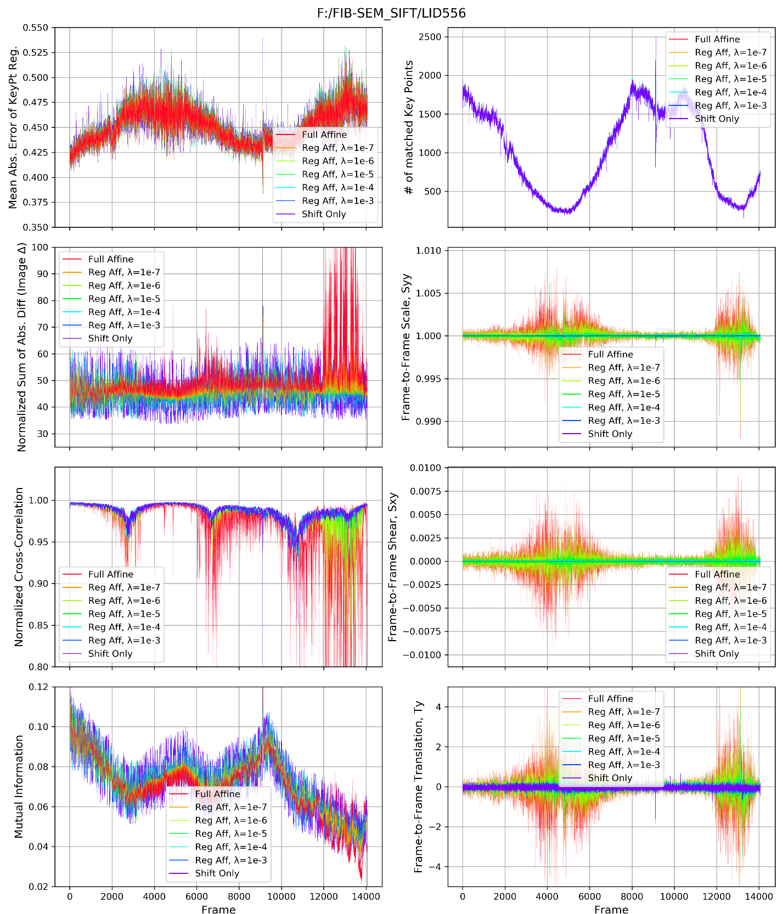

Figure 7. Comparison of results for LID556. Rigid Shift Only transformation produces best values of NSAD, NCC, and MI, but the spreads are high. The best values of NSAD, NCC, and MI that can be obtained with Regularized Affine Transformation (with rigid shift transformation as a target and the regularization parameter λ=10-5) are close to those of Shift Only, but have much lower spread, corresponding to higher consistency.

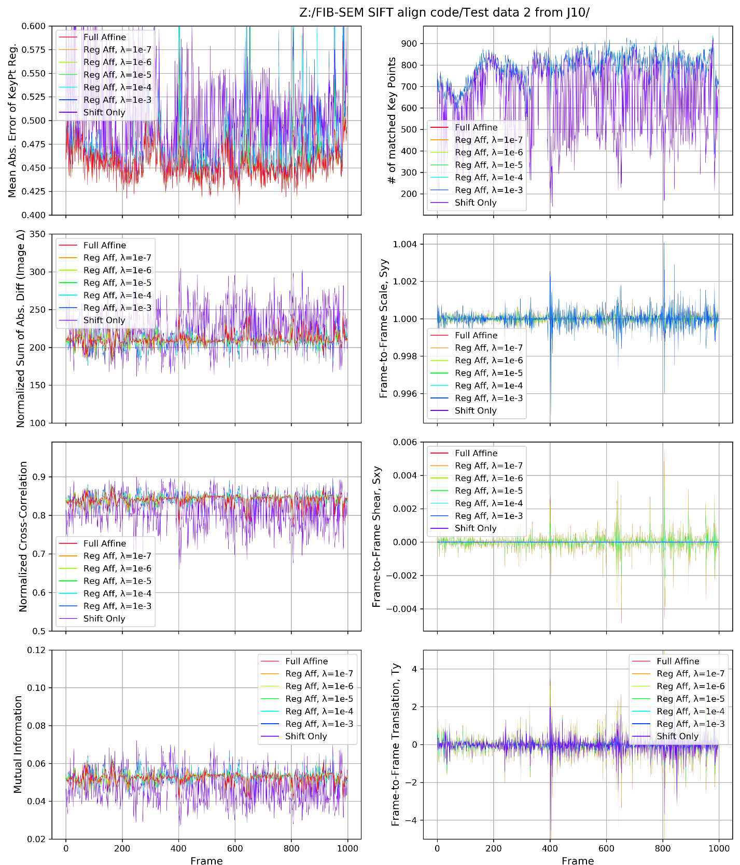

Figure . Comparison of results for U2OS_WTBSA_E030921-4 (J10 data with scale jumps). Rigid Shift Only transformation produces the registration with very high spreads of NSAD, NCC, and MI, and the average values that are not as good as for Affine Transformation. The best values of NSAD, NCC, and MI that can be obtained with full Affine Transformation or Regularized Affine Transformation (with rigid shift transformation as a target and the regularization parameter λ=10-7 ÷ 10-5).

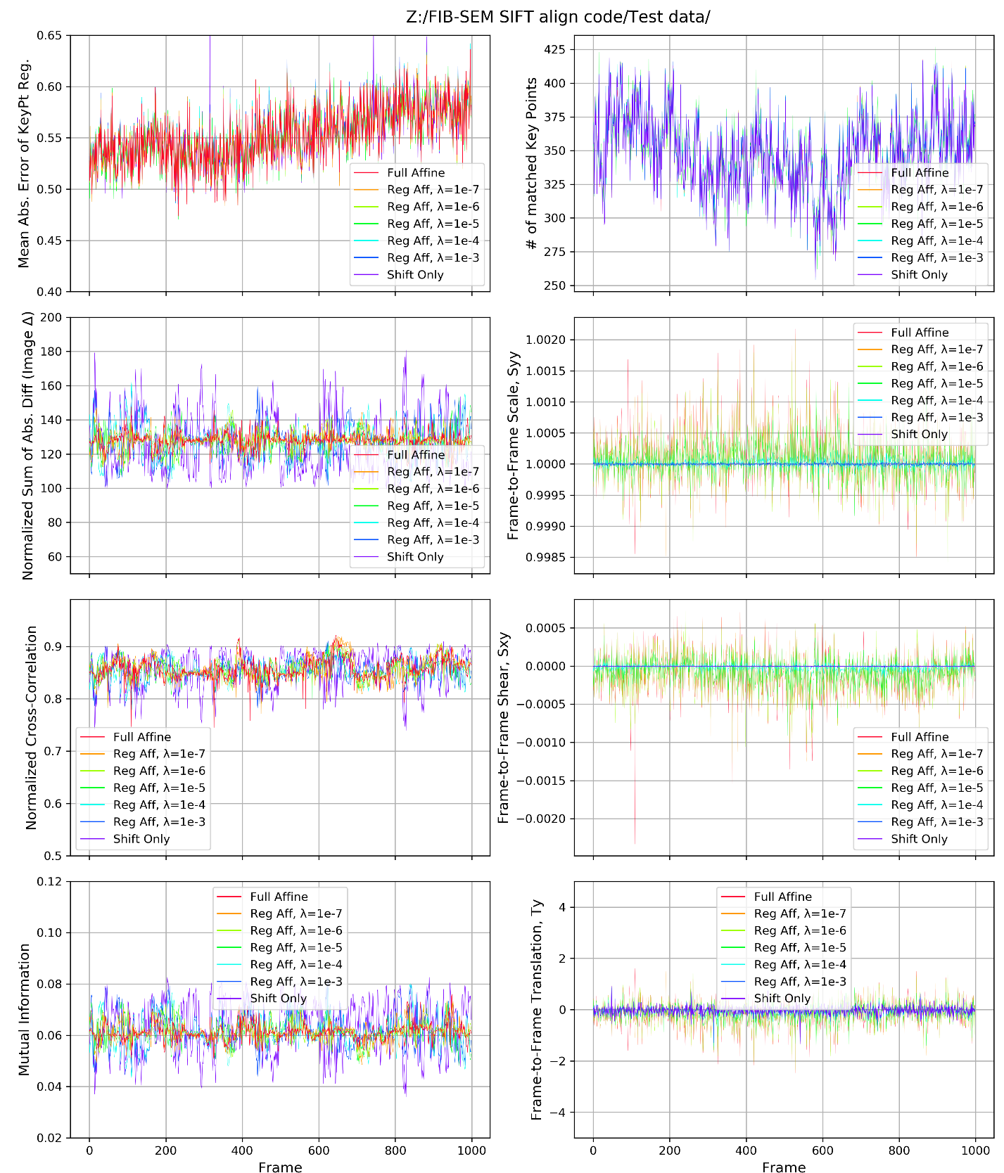

Figure . Comparison of results for U2OS_WTBSA_E030921-4 (no scale jumps). Rigid Shift Only transformation produces the registration with higher spreads of NSAD, NCC, and MI than Affine Transformation. The best values of NSAD, NCC, and MI that can be obtained with full Affine Transformation or Regularized Affine Transformation (with rigid shift transformation as a target and the regularization parameter λ=10-7 ÷ 10-5).

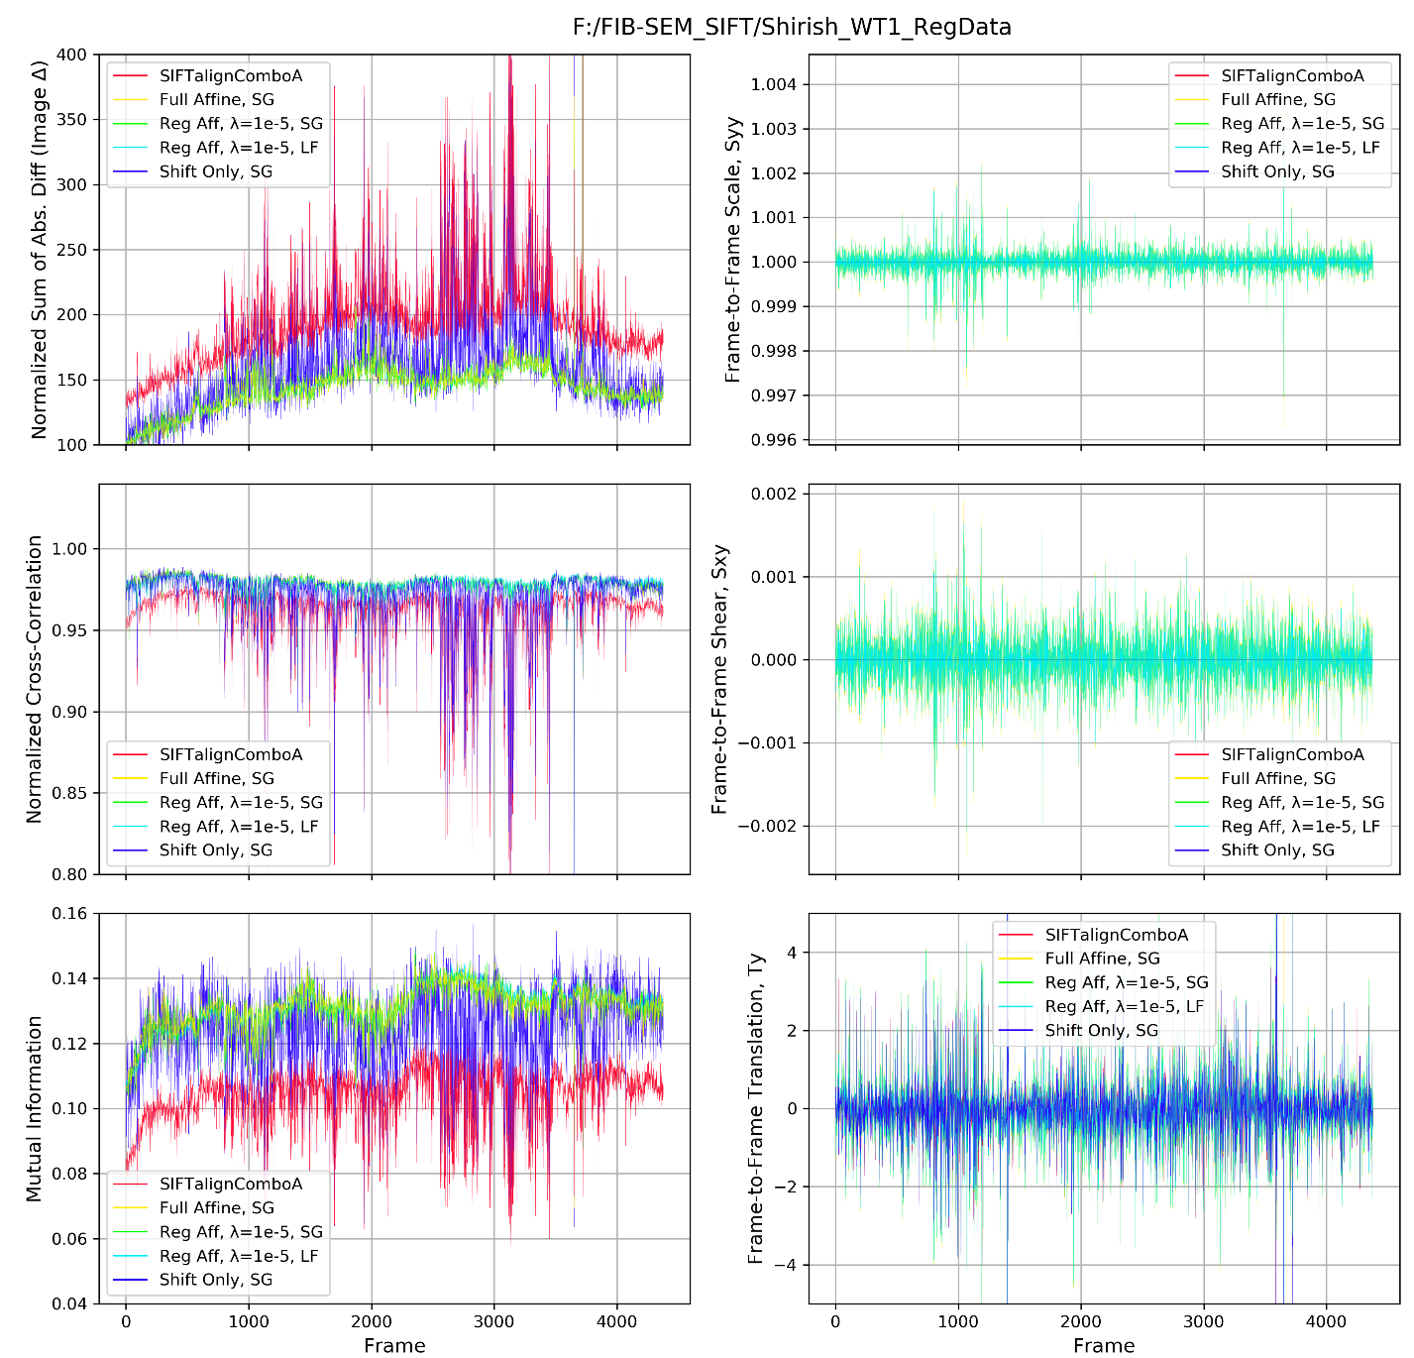

Figure 10. Comparison of results for the data set Shirish WT1. The best results are obtained with either Full (unconstrained) Affine Transformation model, or with Regularized Affine Transformation (with rigid shift transformation as a target and the regularization parameter λ=10-5).

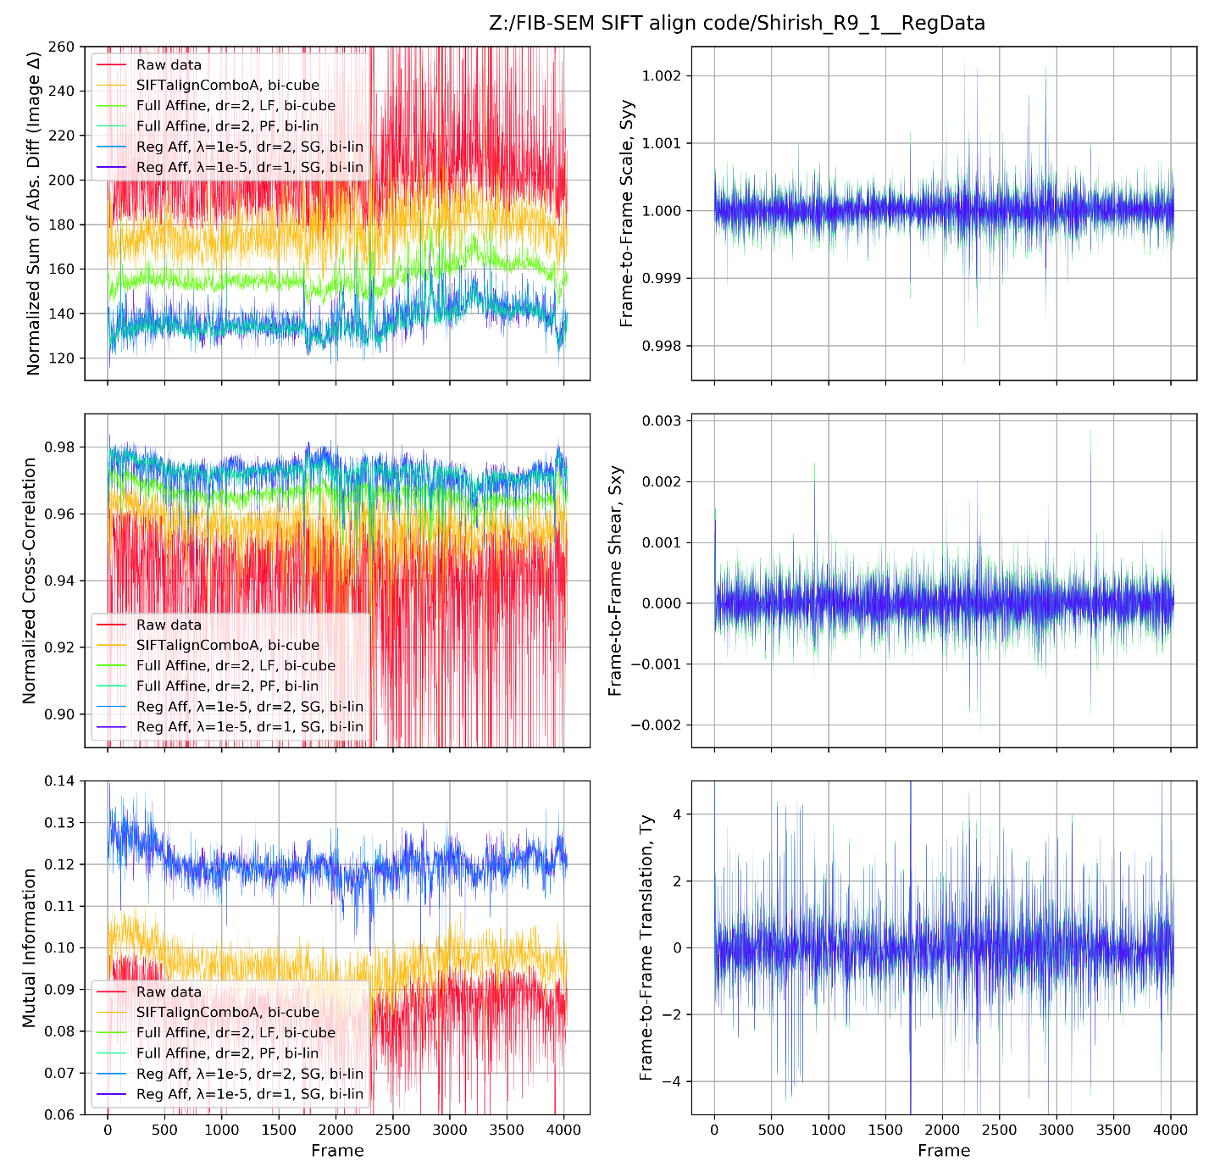

Figure . Comparison of results for the data set Shirish R9_1. The best results are obtained with either Full (unconstrained) Affine Transformation model, or with Regularized Affine Transformation (with rigid shift transformation as a target and the regularization parameter λ=10-5).

Table 1. Comparison of results for different models in Figure 7 (LID556).

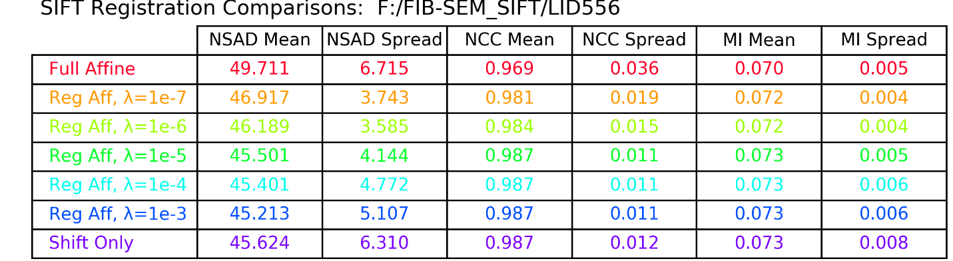

Table 2. Comparison of results for different models in Figure 8 (U2OS_WTBSA_E030921-4 - J10, scale jumps).

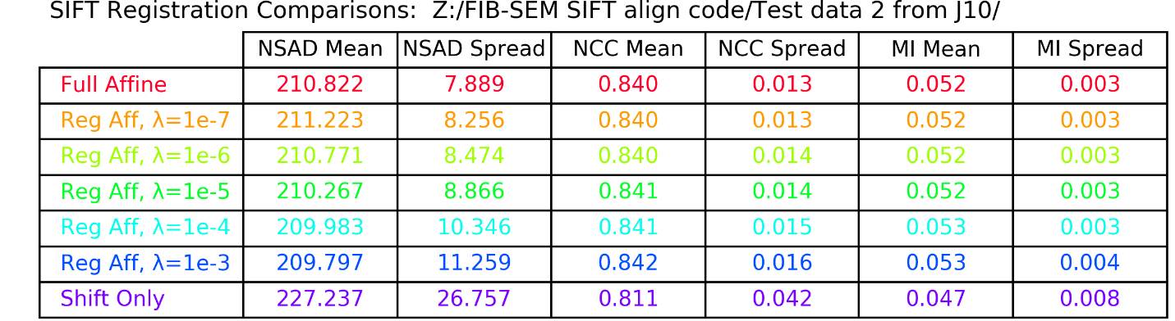

Table 3. Comparison of results for different models in Figure 9 (U2OS_WTBSA_E030921-4 - no scale jumps).

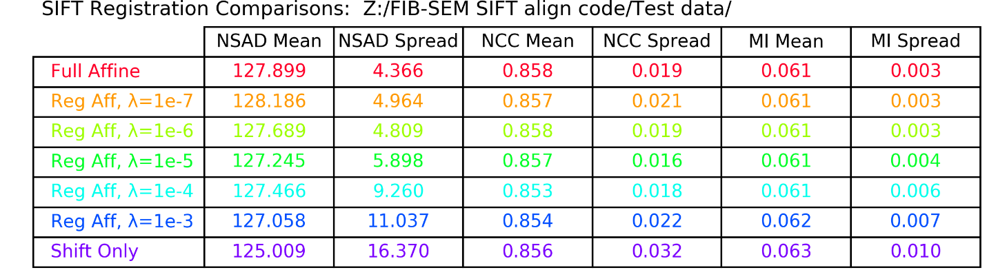

Table 4. Comparison of results for different models in Figure 10 (Shirish W1).

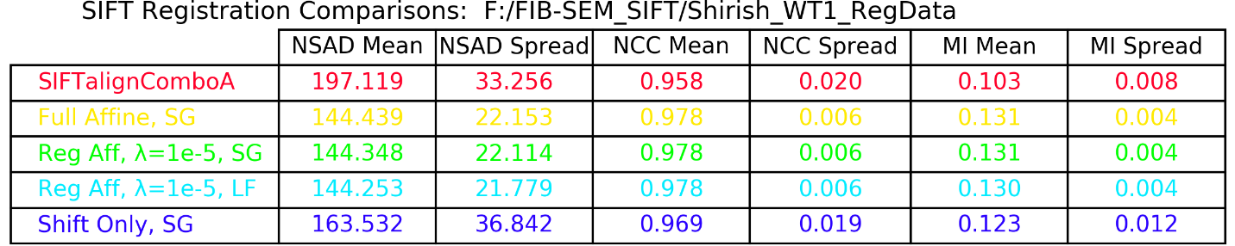

Table . Comparison of results for different models in Figure 11 (Shirish R9_1).

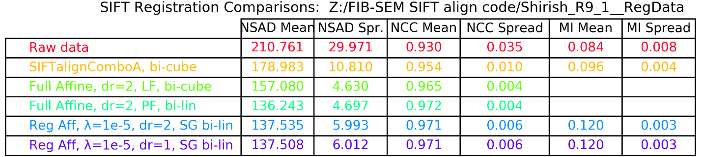

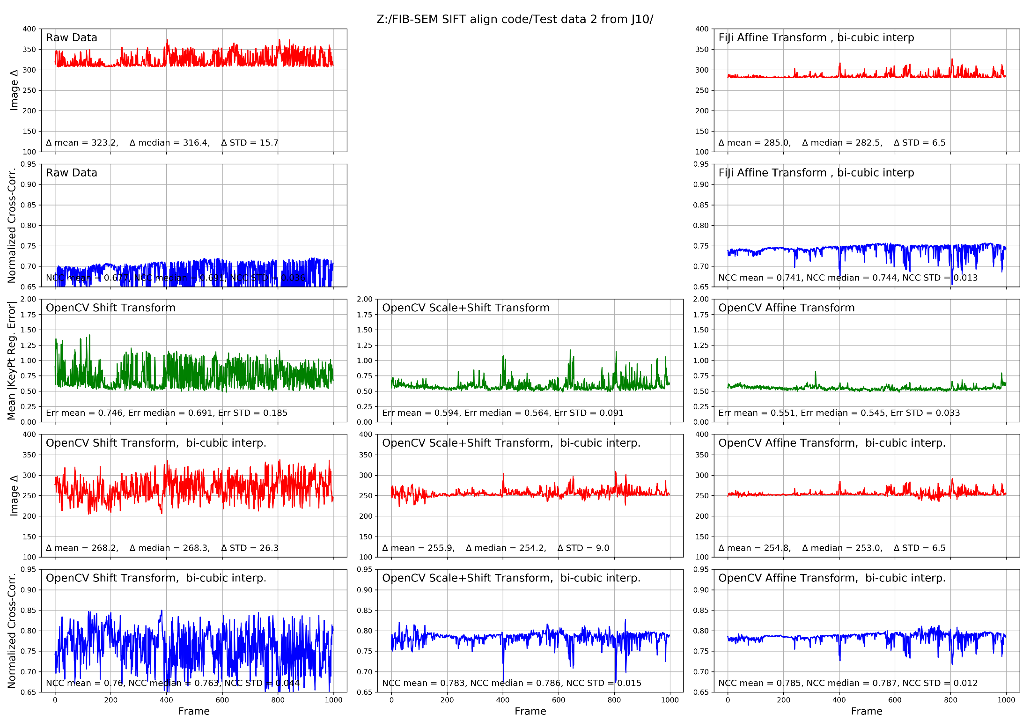

Figure . Data set U2OS_WTBSA_E030921-4 (Gemini450 - J10 data - with scale changes). All results in this table are performed with bi-cubic interpolation.

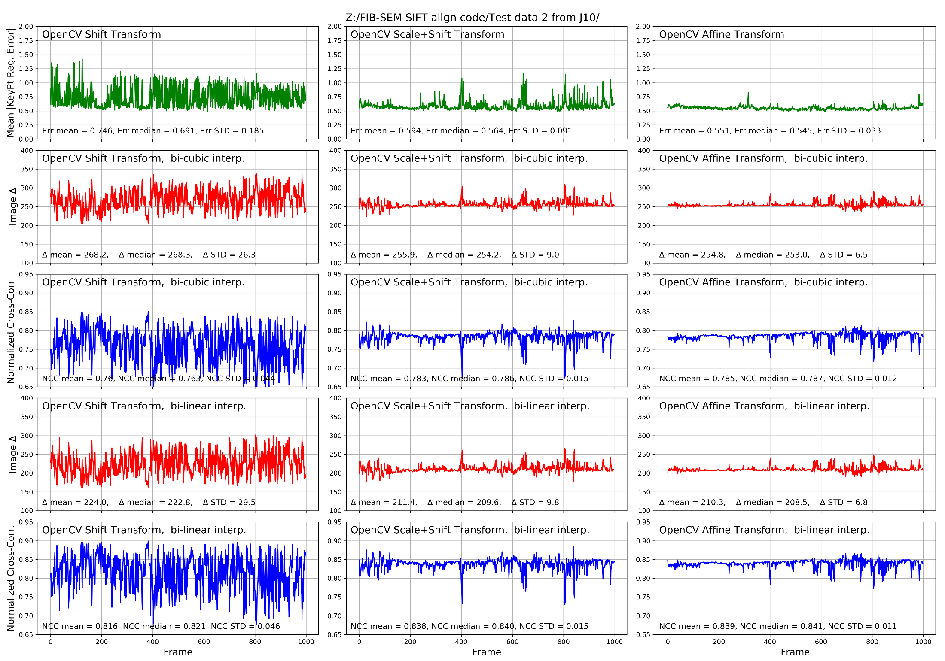

Figure . Data set U2OS_WTBSA_E030921-4 (Gemini450 - J10 data - with scale changes). All results here are for Open CV (Python) workflow.

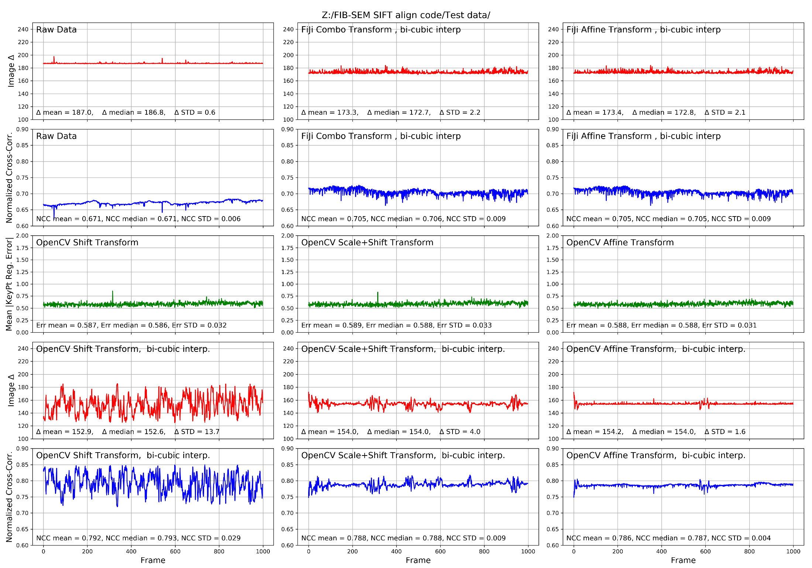

Figure . Data set U2OS_WTBSA_E030921-4 (Merlin-6284 - no abrupt scale changes). All results in this table are performed with bi-cubic interpolation.

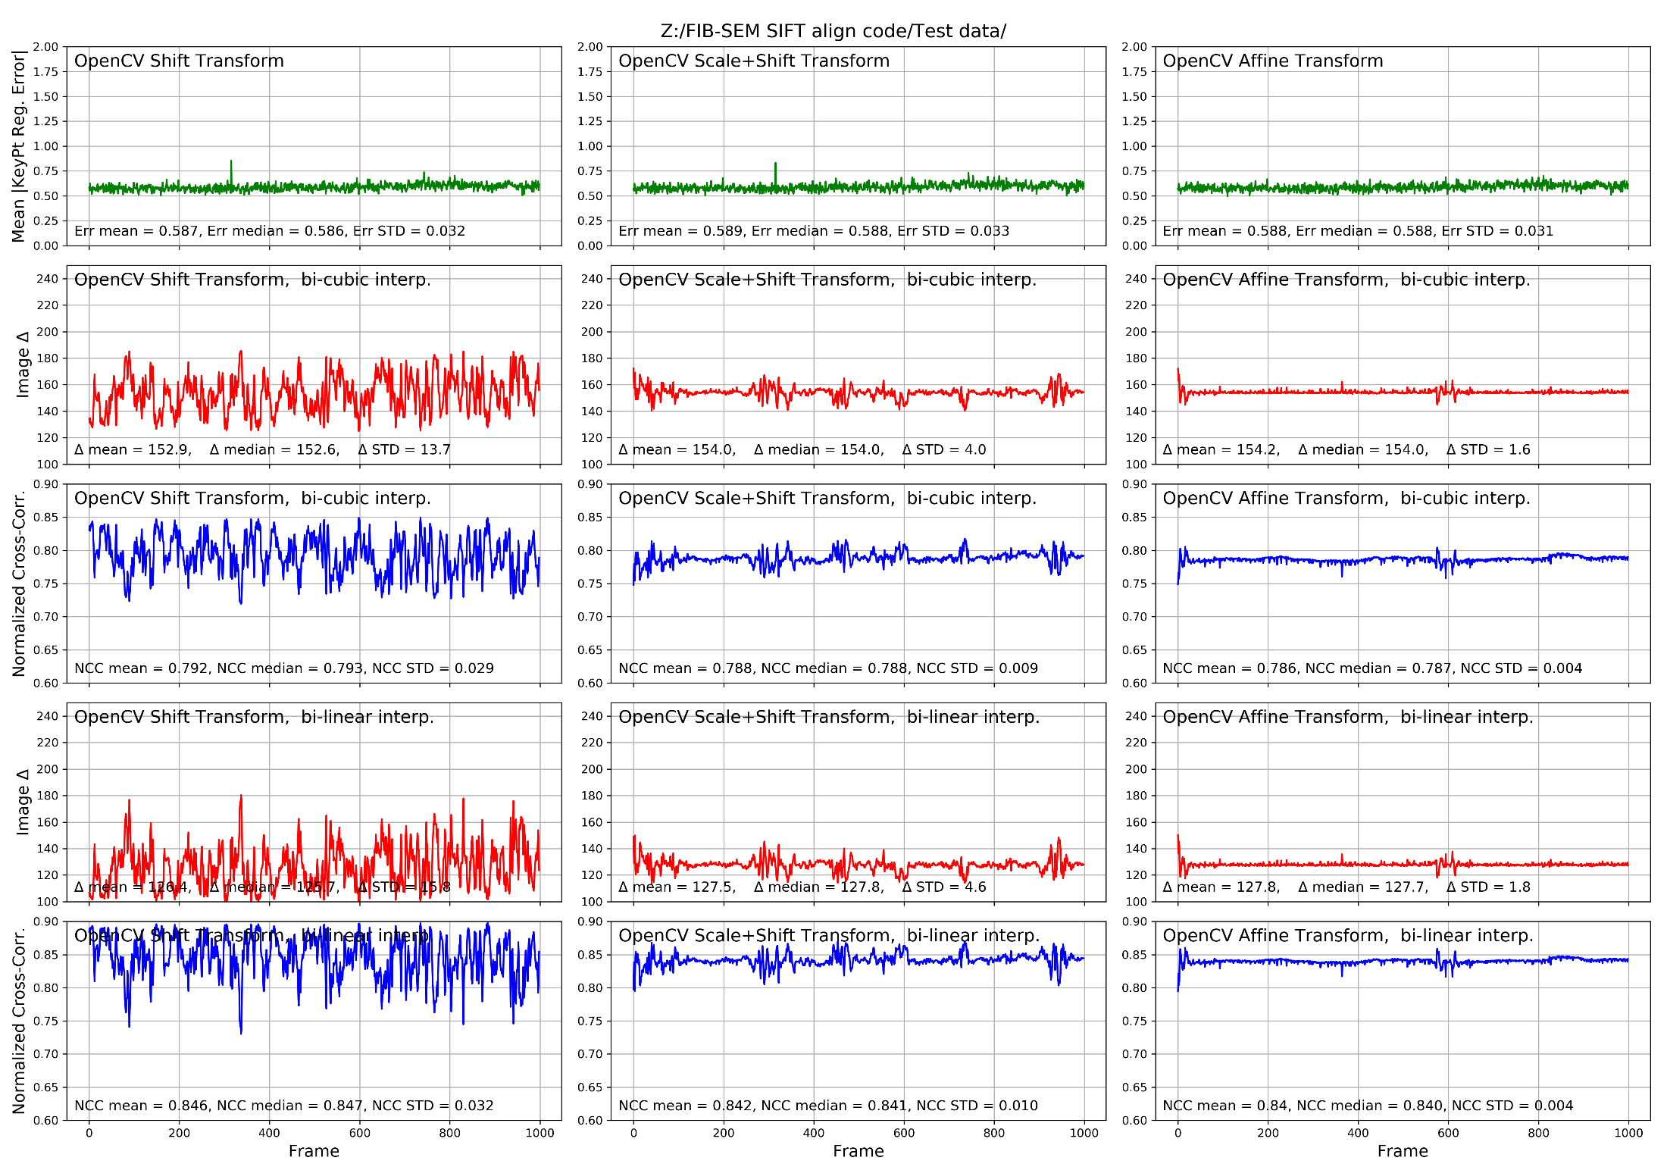

Figure . Data set U2OS_WTBSA_E030921-4 (Merlin-6284 - no abrupt scale changes). All results here are for Open CV (Python) workflow.

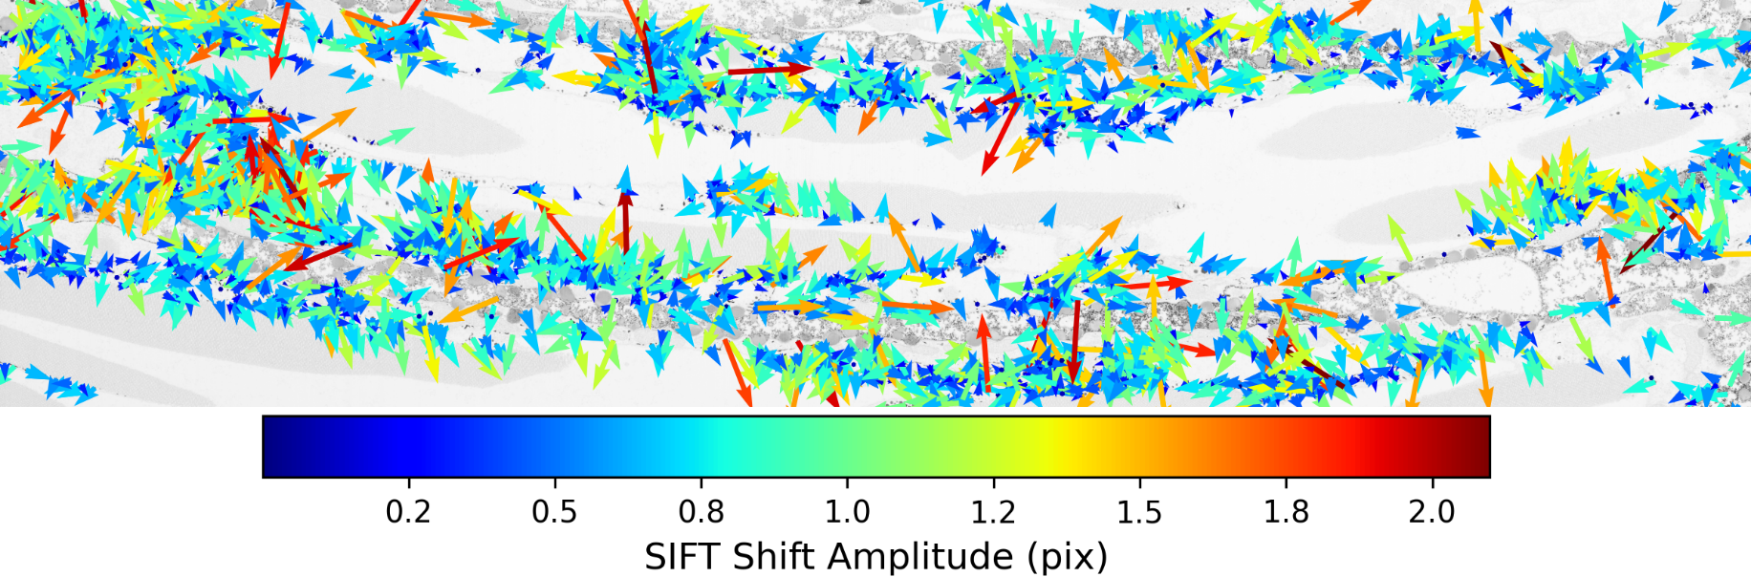

Figure . Data set Shirish_R9_1, imaged on J10 with 4nm voxels, with scale changes.

Table . Data set Shirish_R9_1 (Gemini450 - J10 data, 4nm voxels, with scale changes).

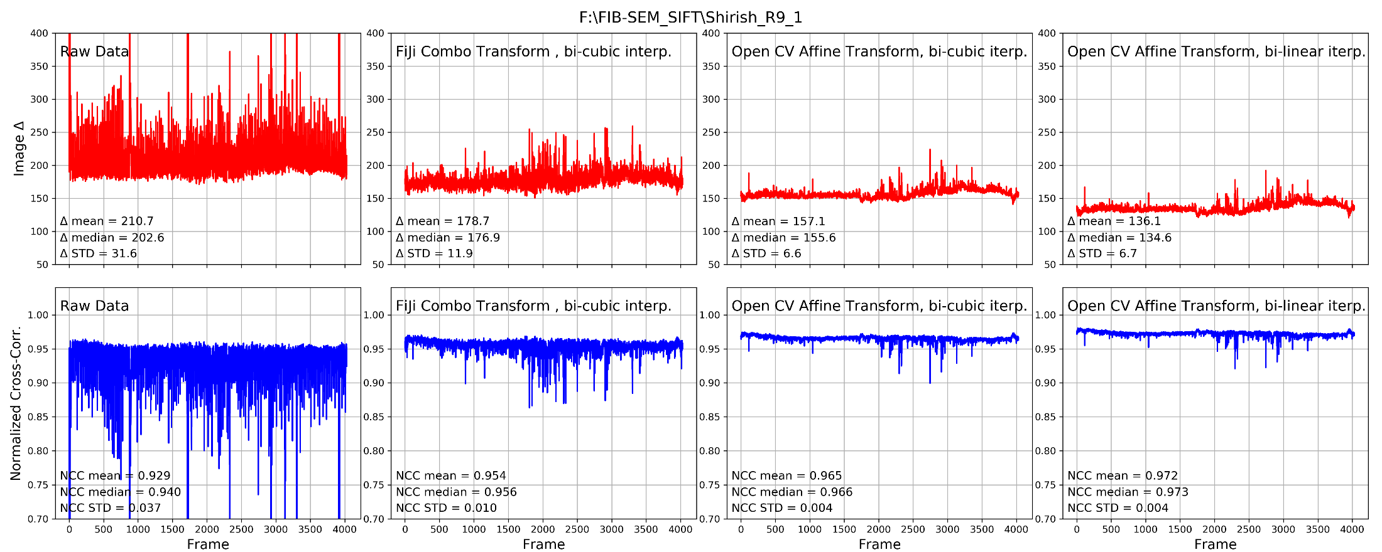

Table 7. U2OS_WTBSA_E030921-4 (Gemini450 - J10 data - with scale changes). Comparison of different methods for keeping the scale constant and shear minimized.

Linear Trend Subtraction

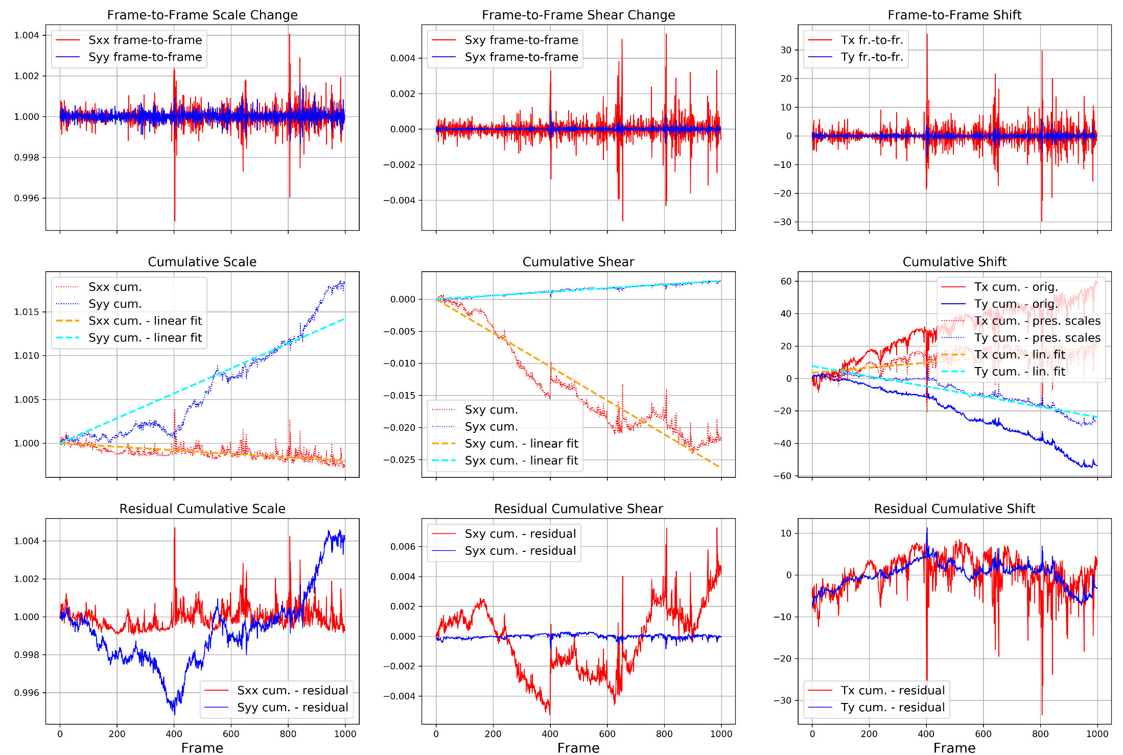

Quadratic Trend Subtraction

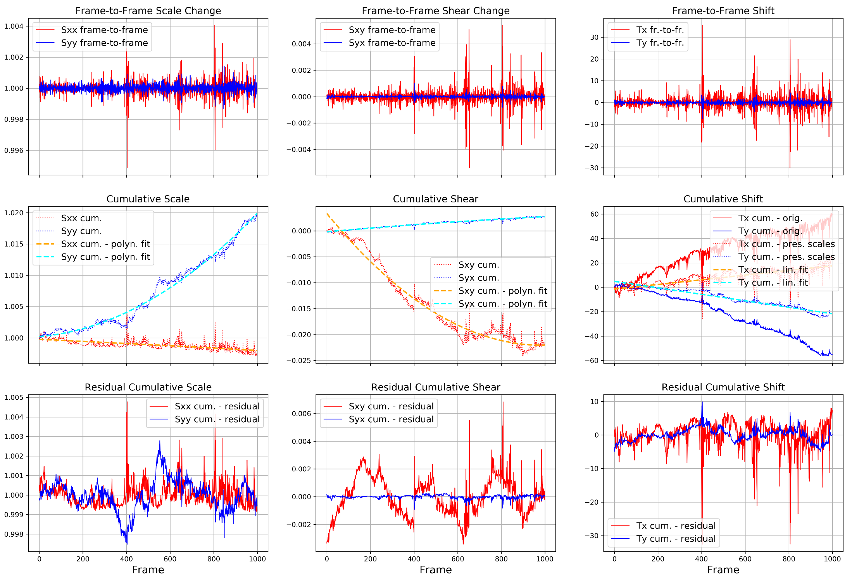

Savitski-Golay Trend Subtraction (window 701, order 3)

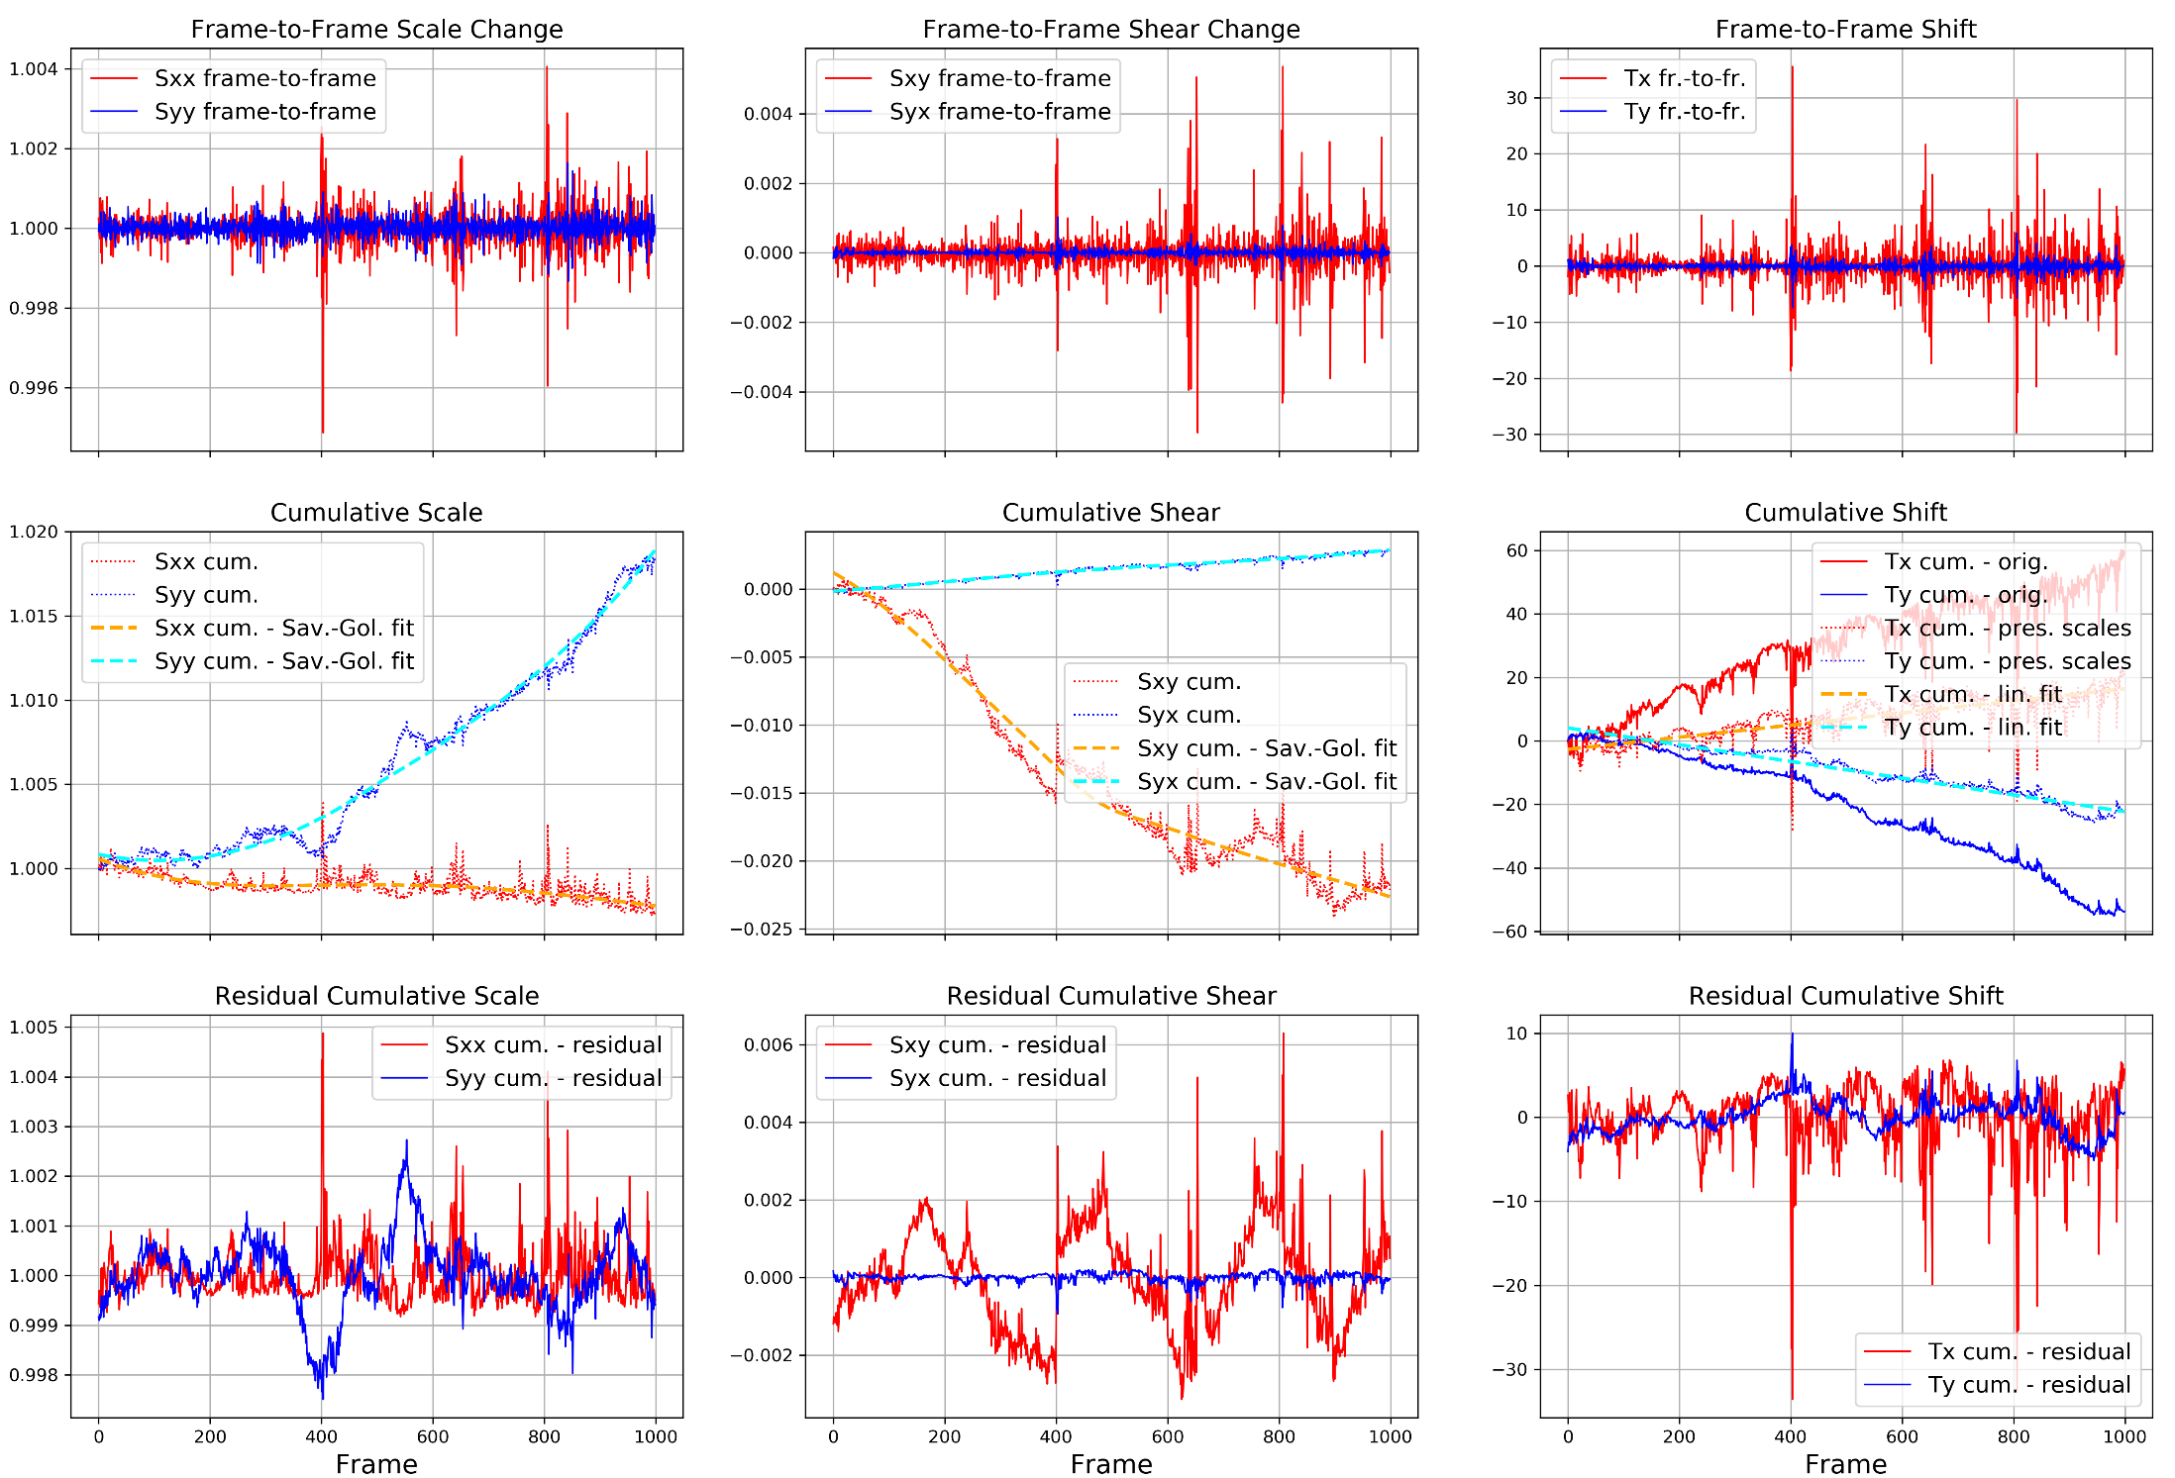

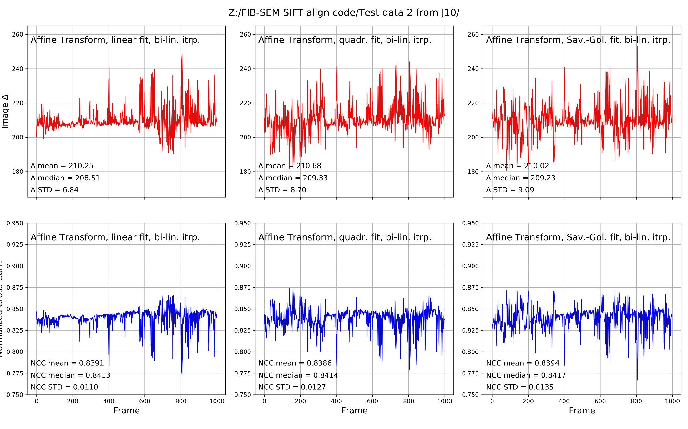

Table . Data set Shirish_R9_1 (Gemini450 - J10 data, 4nm voxes, w. scale changes). Comparison of different methods for keeping the scale constant and shear minimized.

Linear Trend Subtraction

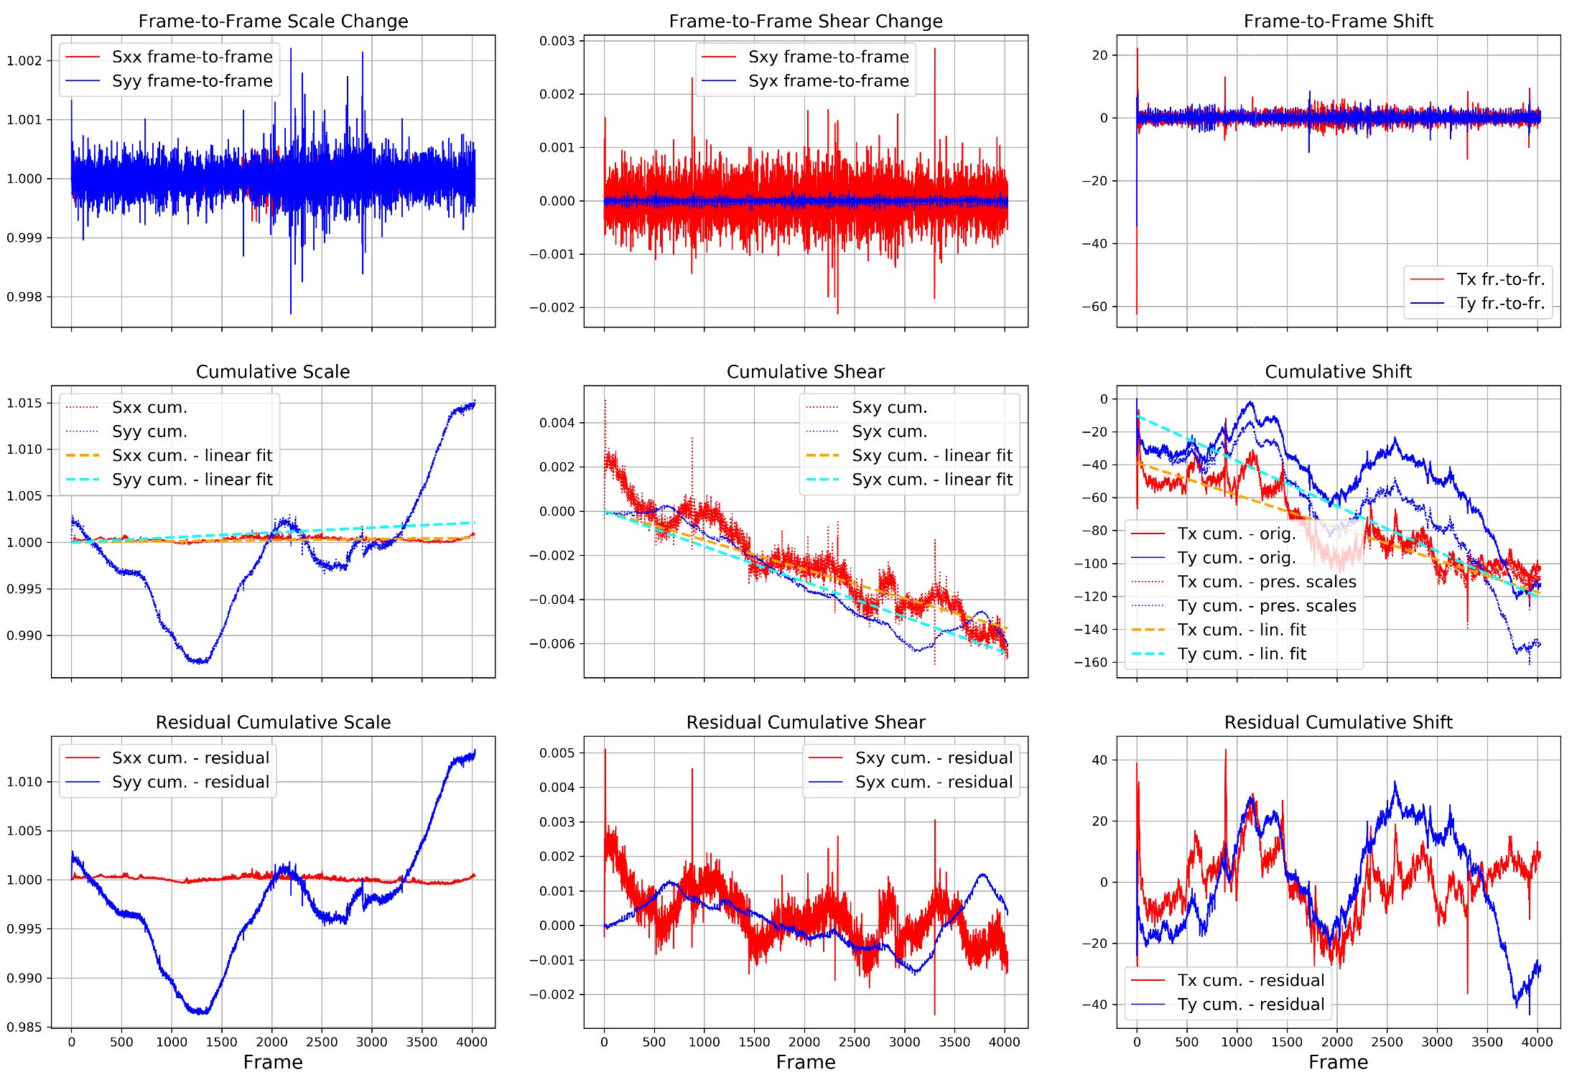

Quadratic Trend Subtraction

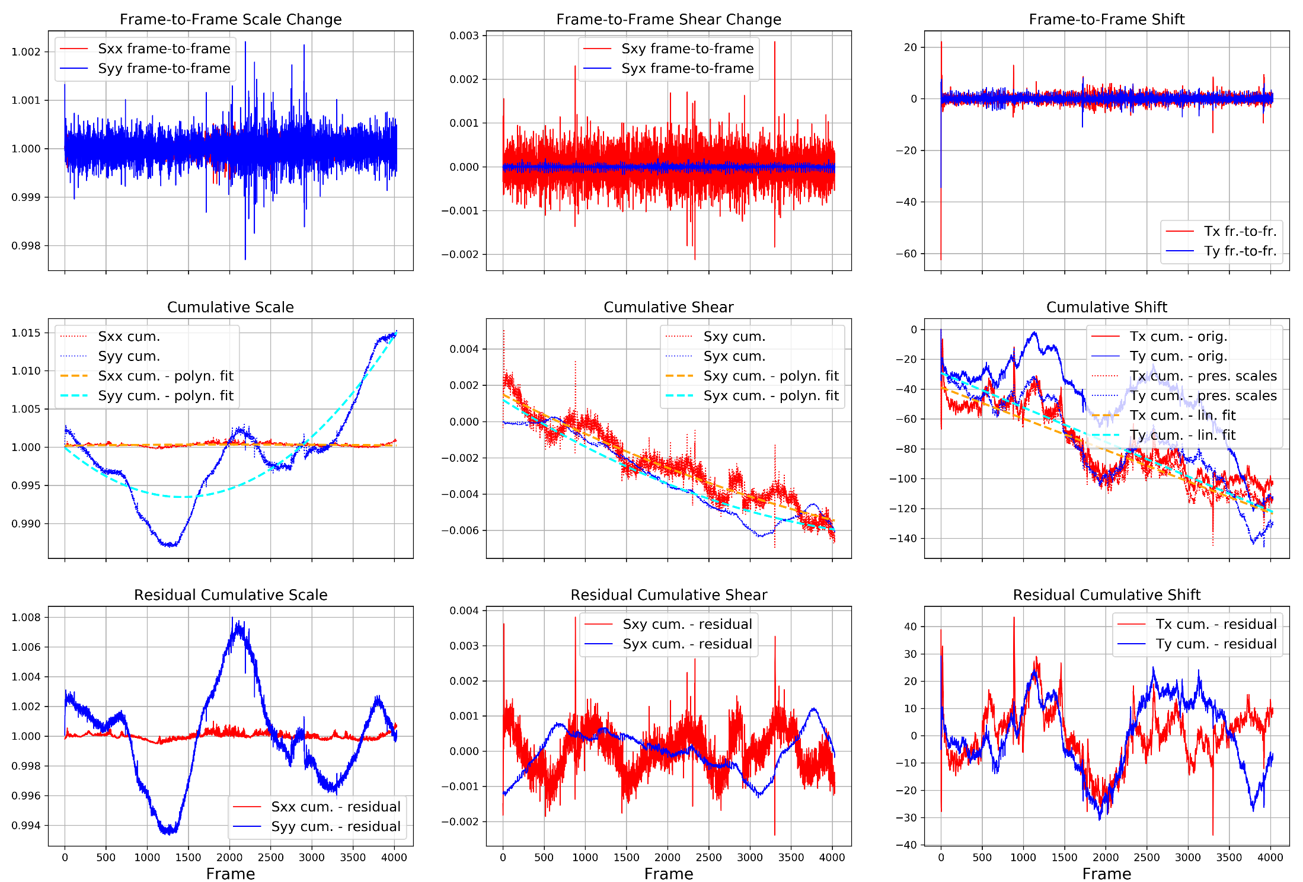

Savitski-Golay Trend Subtraction (window 701, order 3)

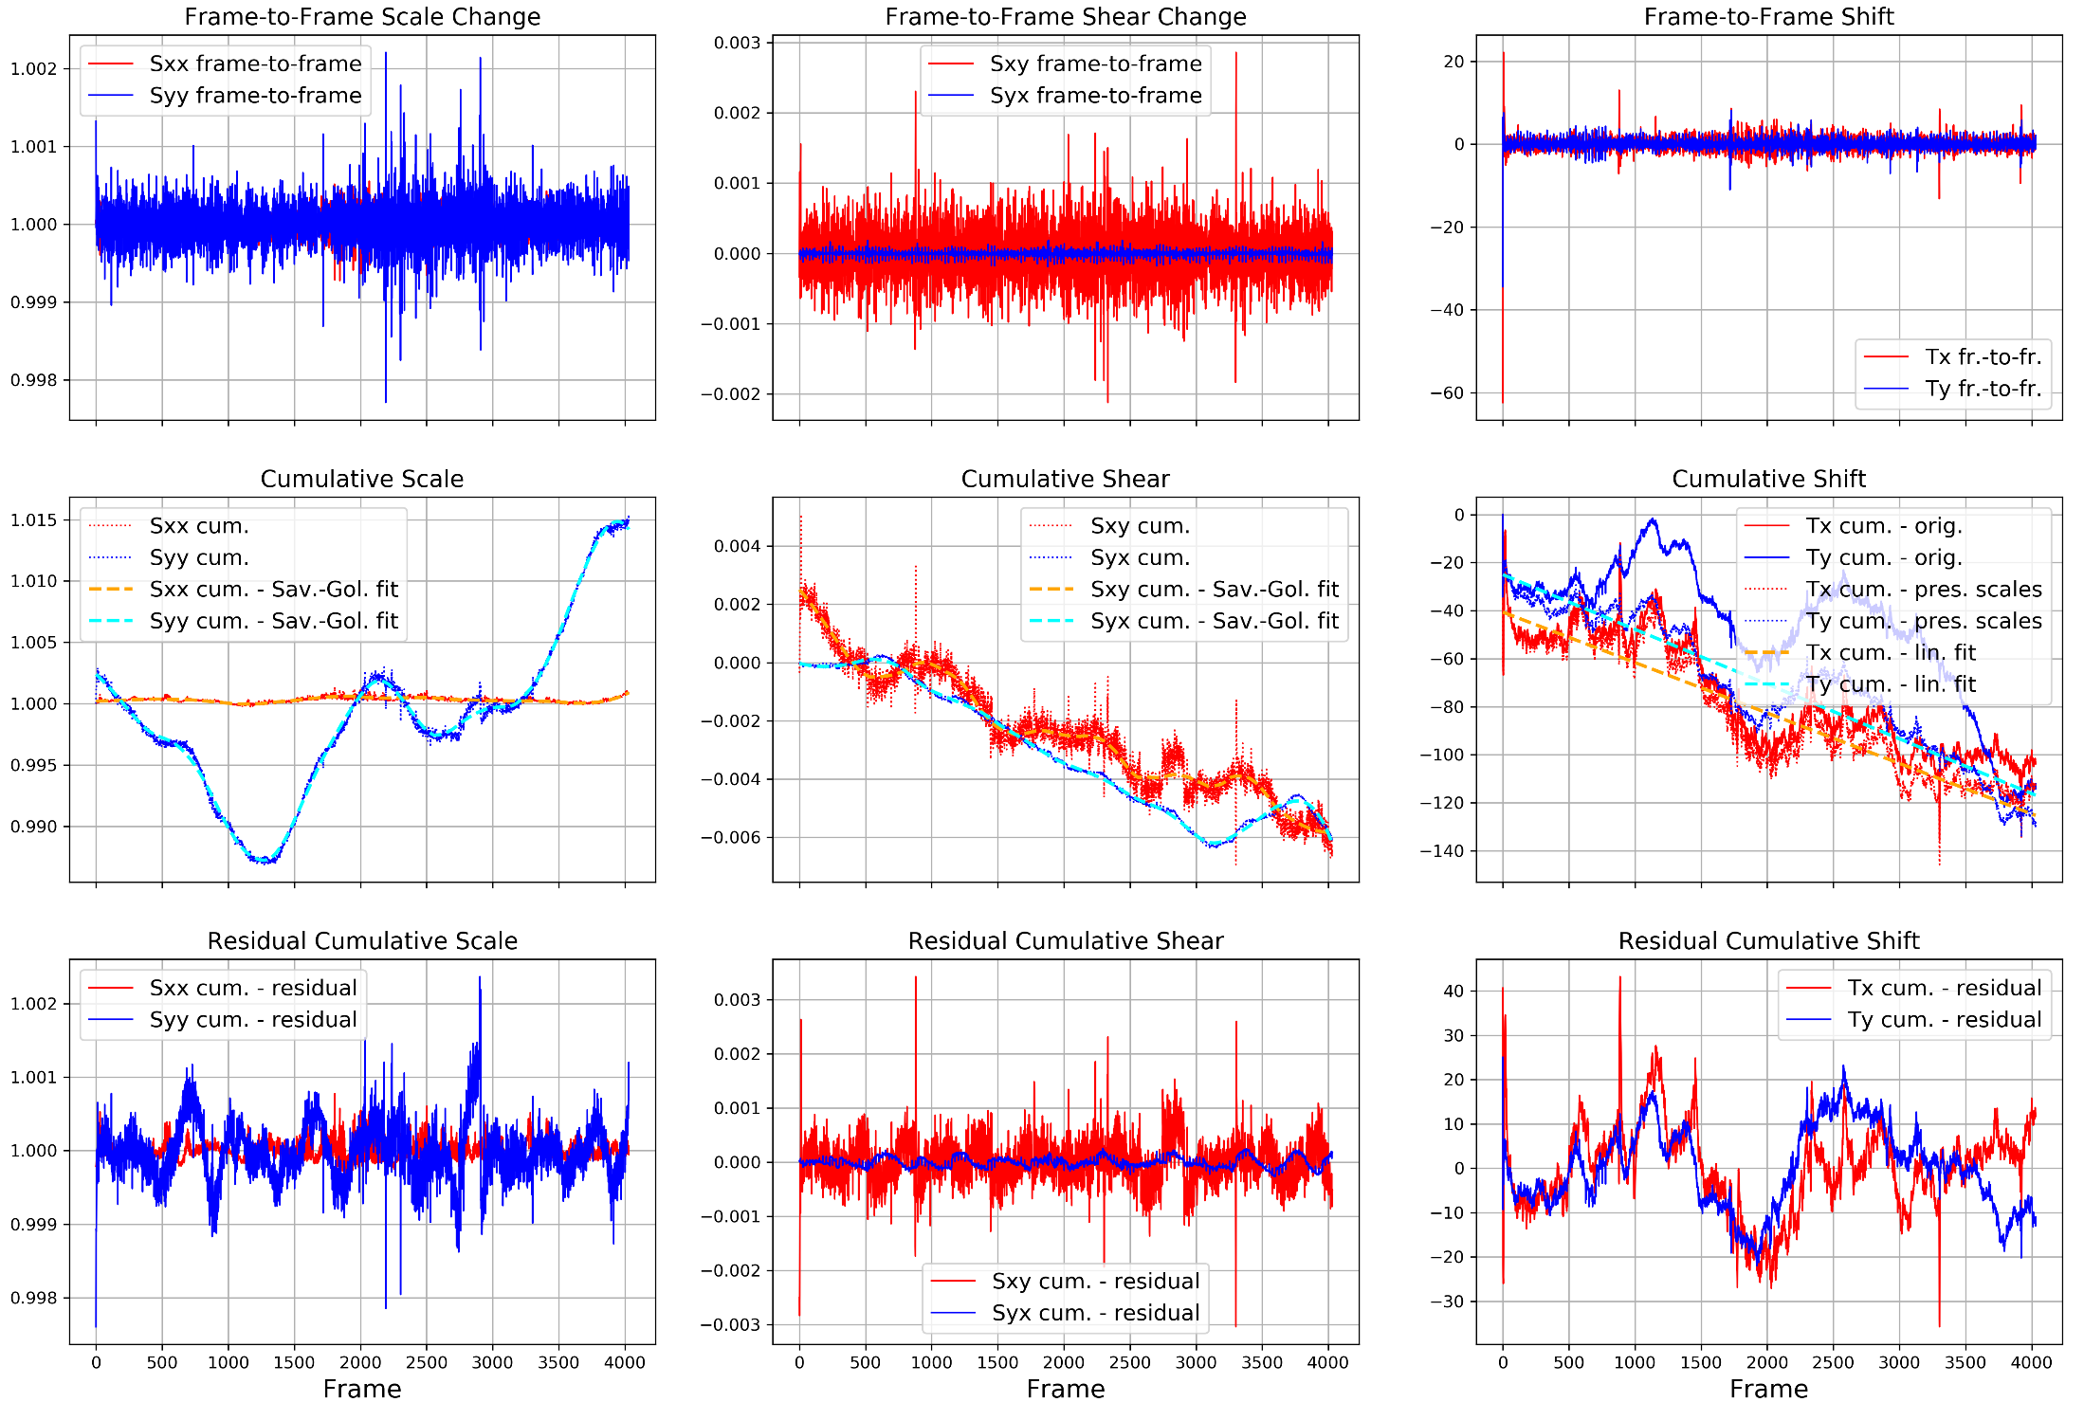

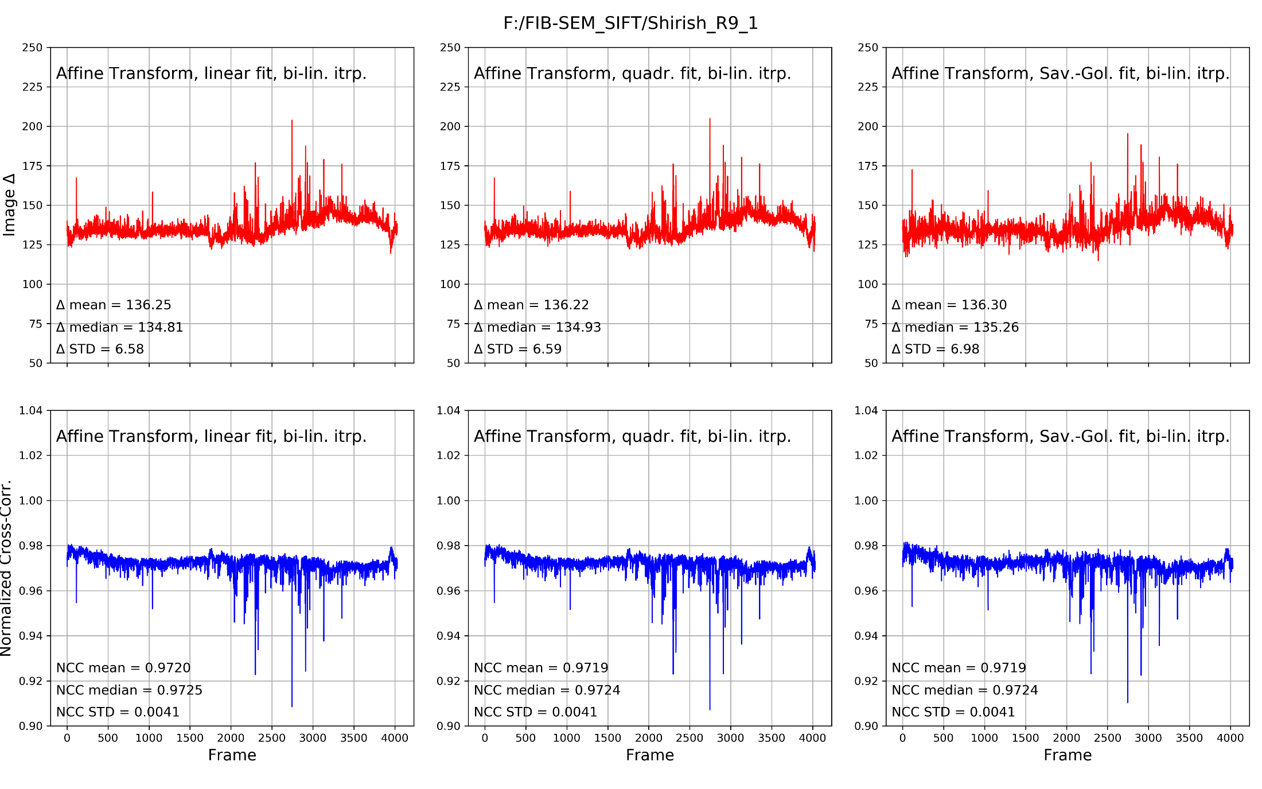

# Appendix 2. FIB-SEM data frame readout and processing

The FIB-SEM data stored during the imaging into binary “.dat” files that contain the header (first 1024 bytes) and the FIB-SEM signal, typically from two detectors.

The class **FIBSEM_frame** initializes an object by reading a FIB-SEM “.dat” file and creating the object with methods performing access to the header information and to the data:

**__init__(filename.dat)** reads the **filename.dat** file and unpacks the header and image information.

**Example:**

*file_name_v8 = 'Merlin-6257_20-02-16_172032_0-0-0.dat'*

*data_dir_v8 = 'F:\FIB-SEM_SIFT\LID494_ROI5_RawData'*

*fname_v8 = os.path.join(data_dir_v8,file_name_v8)*

*frame_v8 = FIBSEM_frame(fname_v8)*

The last line creates the object **frame_v8** and we can then use that object with following methods.

**print_header()** prints the information encoded into the first 1024 bytes of the .dat file.

**display_images()** displays auto-scaled detector images within a python notebook without saving the figure into the file.

**Example:**

After creating the object **frame_v8** as was shown above, the following method can be called:

*frame_v8.display_images()*

This will create this image in the notebook:

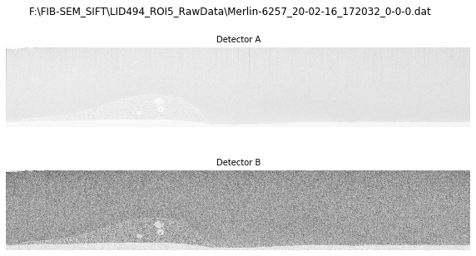

Figure 17. Images created by “*.display_images()*” method

**save_images_jpeg(display_images)** saves autoscaled detector images as a figure in JPG file, (replacing the “.dat” extension with ‘.jpeg’). If the parameter **display_images** is set to **False** (default), the images will not be displayed within the notebook.

**save_images()** saves the images captured by Detector A and Detector B individually as .tif files and adds the ending “_InLens.tif” to the Detector A .tif files and “_ESB.tif” to the Detector B .tif files.

**get_image_min_max(image_name = 'ImageA', thr_min = 1.0e-4, thr_max = 1.0e-3, nbins=256, disp_res = False)** calculates histogram of pixel intensities of a specified image (options are **'ImageA', 'ImageB', 'RawImageA', 'RawImageB'**, default is **'ImageA'**) with number of bins determined by parameter **nbins** (default = 256) and normalizes it to get the probability distribution function (PDF), from which a cumulative distribution function (CDF) is calculated. Then given the **thr_min, thr_max** parameters, the minimum and maximum values for the image are found by finding the intensities at which CDF= **thr_min** and (1- **thr_max**), respectively. Figure 18 illustrates the process for the data shown in Figure 17, the parameters are **nbins**=256 and **thr_min, thr_max** = 0.02 (left) and 0.001 (right).

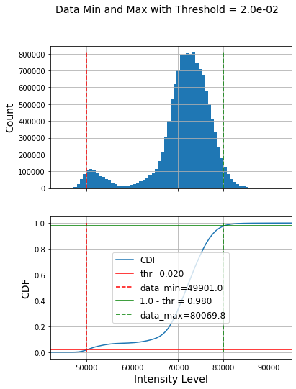 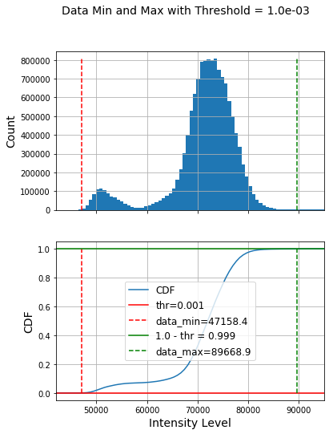

Figure 18. Data Min and Max determined by the method “get_image_min_max”, the results for the frame shown in Figure 17 with nbins=256 and threshold = 0.02 (left) and 0.001 (right).

**RawImageA_8bit_thresholds(thr_min, thr_max, data_min, data_max, nbins)** and **RawImageB_8bit_thresholds (thr_min, thr_max, data_min, data_max, nbins)** will first check if the image is already in 8-bit form, if not, it will convert the image to 8-bit form using the minimum (**data_min**) and maximum(**data_max**), if those are given, and the **thresholds** (using the same procedure as explained above), if the **data_min** and **data_max** are not provided (or are equal – default values are set to -1 for each).

**save_snapshot(self, display , dpi, nbins, thr_min, thr_max)** creates a snapshot of the frame as shown below, which includes the detector images and some information from the header.

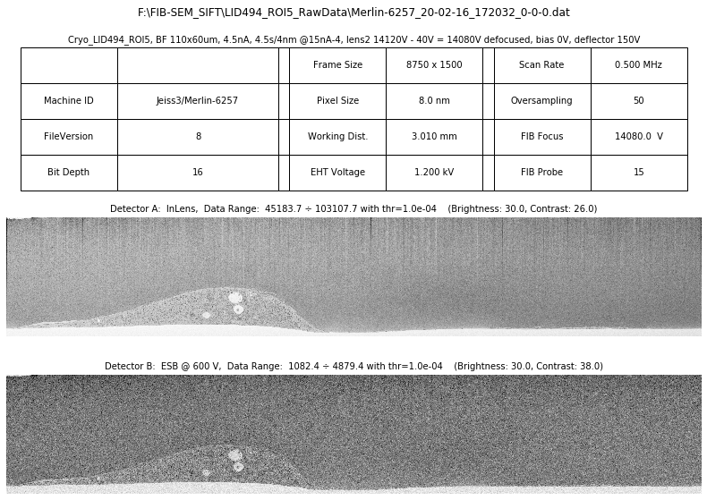

Figure 19. A snapshot created by “.save_snapshot()” method.

# Appendix 2. Details on the implementation steps in the process of FIB-SEM stack registration using SIFT

FIB-SEM stack registration is performed using Scale-Invariant Feature Transform (SIFT) algorithm (*1*). There are many publicly available implementations of SIFT, this program uses the SIFT package that is a part of OpenCV library (*18*). Some details of the implementation are given in the following Sections.

## Extract Keypoints and descriptors for each frame.

This step uses the function **sift.detectAndCompute(img, None)** in the OpenCV library (SIFT environment needs to be setup first by executing the line **sift=cv2.xfeatures2d.SIFT_create()**). It returns the Keypoints and Descriptors. DASK package (*19*) is used to parallelize the process.

## Packaging / Unpackaging Key Points.

We found that Key Points and descriptors need to be save into separate files (one per frame) for subsequent steps. Keeping them in memory slows down processing. We pickle (*20*) - a procedure that is used for packing the data objects into binary entities. OpenCV Key Points cannot be serialized using pickle (*21*, *22*) (apparently Key-Points have some attributes that cannot be "pickled"). But apparently these attributes are not critically important for key-point matching. So, we used simple procedures to convert Key Point objects to lists prior to saving them into binary files and then convert them back from lists to Key Point objects after subsequent read-back.

## Find Key Point matches and determining the Transformation Matrices for each consecutive pair of FIB-SEM frames.

Two procedures for Key Point matching available in OpenCV and have been evaluated (and can be used) – Brute Force (BF) matcher and Fast Library for Approximate Nearest Neighbors (FLANN) matcher.

BF matcher takes the descriptor of one feature in the first image and matches it with all other features in second image using some distance calculation. The closest match in the second image is returned. BF matcher is implemented as follows:

*bf = cv2.BFMatcher()*

*matches = bf.knnMatch(des1,des2,k=2)*

FLANN contains a collection of algorithms optimized for fast nearest neighbor search in large datasets and for high dimensional features. It works faster than BF matcher for large datasets.

FLANN matcher is implemented as follows:

*FLANN_INDEX_KDTREE = 1*

*index_params = dict(algorithm = FLANN_INDEX_KDTREE, trees = 5)*

*search_params = dict(checks = 50)*

*flann = cv2.FlannBasedMatcher(index_params, search_params)*

*matches = flann.knnMatch(des1, des2, k=2)*

Once the initial matching has been performed, Lowe Ratio Test(*1*, *23*) is applied to further narrow down the list of matches:

*good = []*

*for m, n in matches:*

*if m.distance < 0.7*n.distance:*

*good.append(m)*

Each Key Point of the first image is matched with several Key Points from the second image. We keep the two best matches for each Key Point (those with the smallest distance measurement). Lowe's test checks that the distances for these two best matches are sufficiently different. If they are not, then the Key Points is removed from further consideration.

Few more steps for filtering out bad matches can be performed after this.

A commonly used way of selecting only good Key Points while determining the best transformation is to use RANSAC algorithm (*15*).

Alternatively, iterative linear regression with “Throw away the worst outlier” heuristic can be used. For each *i-th* matched pair of Key Points, the error is calculated as ${Error}_{i}=\left|{Dst.Point}_{i}-M*{Src.Point}_{i}\right|$. The iterative procedure throws away the matched Key Point pair with worst error on every iteration until the worst error falls below **drmax** or the max number of iterations is reached.

## Implementation of Regularized Affine Transformation

For a given set of matched key Points, src_pts and dst_pts, the transformation matrix assuming Regulirized Affine Transformation is determined using the procedure ***determine_regularized_affine_transform(src_pts, dst_pts, l2_matrix = None, targ_vector = None)***:

*def determine_regularized_affine_transform(src_pts, dst_pts, l2_matrix = None, targ_vector = None):*

"""Estimate N-D affine transformation with regularization from a set of corresponding points.

We can determine the over-, well- and under-determined parameters with the total least-squares method.

Number of source and destination coordinates must match.

The transformation is defined as:

X = (a0*x + a1*y + a2)

Y = (b0*x + b1*y + b2)

This is regularized Affine estimation - it is regularized so that the penalty is for deviation from a target (default target is rigid shift) transformation

a0 =1, a1=0, b0=1, b1=1 are parameters for target (shift) transform. Deviation from these is penalized.

The coefficients appear linearly so we can write

A x = B, where:

A = [[x y 1 0 0 0]

[0 0 0 x y 1]]

Htarget.T = [a0 a1 a2 b0 b1 b2]

B.T = [X Y]

In case of ordinary least-squares (OLS) the solution of this system

of equations is:

H = np.linalg.inv(A.T @ A) @ A @ B

In case of least-squares with Tikhonov-like regularization:

H = np.linalg.inv(A.T @ A + Γ.T @ Γ) @ (A @ B + Γ.T @ Γ @ Htarget)

where Γ.T @ Γ (for simplicity will call it L2 vector) is regularization term and Htarget

is a target solution, deviation from which is minimized in L2 sense

"""

*src_matrix, src = _center_and_normalize_points_gs(src_pts)*

*dst_matrix, dst = _center_and_normalize_points_gs(dst_pts)*

*n, d = src.shape*

*n2 = n*n* # normalization factor, so that shrinkage parameter does not depend on the number of points

*A = np.zeros((n * d, d * (d + 1)))*

# fill the A matrix with the appropriate block matrices; see docstring

# for 2D example — this can be generalised to more blocks in the 3D and

# higher-dimensional cases.

*for ddim in range(d):*

*A[ddim*n : (ddim + 1) * n, ddim * (d + 1) : ddim * (d + 1) + d] = src*

*A[ddim*n : (ddim + 1) * n, ddim * (d + 1) + d] = 1*

*AtA = A.T @ A / n2*

*if l2_matrix is None:*

*l2 = 1.0e-5* # default shrinkage parameter

*l2_matrix = np.eye(2 * (d + 1)) * l2*

*for ddim in range(d):*

*ii = (d + 1) * (ddim + 1) - 1*

*l2_matrix[ii,ii] = 0*

*if targ_vector is None:*

*targ_vector = np.zeros(2 * (d + 1))*

*targ_vector[0] = 1*

*targ_vector[4] = 1*

*Hp = np.linalg.inv(AtA + l2_matrix) @ (A.T @ dst.T.ravel() / n2 + l2_matrix @ targ_vector)*

*Hm = np.eye(d + 1)*

*Hm[0:d, 0:d+1] = Hp.reshape(d, d + 1)*

*H = np.linalg.inv(dst_matrix) @ Hm @ src_matrix*

*return H*

# Appendix 3: Optimization of parameters used during SIFT Key Point discovery and matching.

## Choosing optimal thresholds.

As mentioned above, SIFT implementation of OpenCV uses 8-bit images. When the images are converted from 16-bit into 8-bit, some information is lost, particularly if the data range is chosen too wide. Therefore, the choice of **threshold** parameters (**thr_min** and **thr_max**), described above, is important. Presented in Table 9 are the results of the Key Point discovery and matching performed on two data sets. As can be seen, when the **threshold** is set too low, the data range is too broad and the number of Key Points is low, most probably because of the information loss during I16 to I8 conversion. On the other hand, when the **threshold** parameter is set too high, the number of Key Points is much higher, but also the calculation time will become higher unless proper **kp_max_num** value is set).

This will also be useful for final step - saving the data if the data is saved into 8-bit format. This step uses the method **get_min_max_ImageA_thresholds(thr_min**, **thr_max, nbins)** with all frames and then finds minimum of all minima and maximum of all maxima, **threshold** value is most likely between 10-3 and 10-5. It may be worthy further investigation, but at this point it seems that setting the **thr_min** = 3*10-5 and **thr_max** = 10-4 is reasonable. The reason **thr_max** setting is higher is because usually the FIB-SEM signal has “fatter” tail at the high values.

Table 9. Results of the Key Point discovery and matching performed on two data sets with three different values of threshold parameter.

|  |  |
| --- | --- |
| Sample: U2OS_WTBSA_E030921-4 | Sample: Cryo_LID494_ROI5 |
|  |  |
|  |  |
|  |  |
|  |  |

Figure 20. The differences between the frame shifts calculated for the set U2OS_WTBSA_E030921-4 using different matchers, filters, and thresholds.

# References

1. D. G. Lowe, Distinctive Image Features from Scale-Invariant Keypoints. *Int. J. Comput. Vis.* **60**, 91–110 (2004).

2. K. S. Arun, T. S. Huang, S. D. Blostein, Least-Squares Fitting of Two 3-D Point Sets. *IEEE Trans. Pattern Anal. Mach. Intell.* **PAMI-9**, 698–700 (1987).

3. B. K. P. Horn, Closed-form solution of absolute orientation using unit quaternions. *JOSA A*. **4**, 629–642 (1987).

4. S. Umeyama, Least-squares estimation of transformation parameters between two point patterns. *IEEE Trans. Pattern Anal. Mach. Intell.* **13**, 376–380 (1991).

5. R. Hartley, A. Zisserman, *Multiple view geometry in computer vision* (Cambridge University Press, Cambridge, 2004; http://public.eblib.com/choice/publicfullrecord.aspx?p=256634).

6. A. E. Hoerl, R. W. Kennard, Ridge Regression: Biased Estimation for Nonorthogonal Problems. *Technometrics*. **42**, 80–86 (2000).

7. J. Hennies, J. M. S. Lleti, N. L. Schieber, R. M. Templin, A. M. Steyer, Y. Schwab, AMST: Alignment to Median Smoothed Template for Focused Ion Beam Scanning Electron Microscopy Image Stacks. *Sci. Rep.* **10**, 2004 (2020).

8. R. Tibshirani, Regression Shrinkage and Selection Via the Lasso. *J. R. Stat. Soc. Ser. B Methodol.* **58**, 267–288 (1996).

9. K. Khairy, G. Denisov, S. Saalfeld, Joint Deformable Registration of Large EM Image Volumes: A Matrix Solver Approach. *ArXiv180410019 Cs* (2018) (available at http://arxiv.org/abs/1804.10019).

10. J. Kybic, M. Unser, Fast parametric elastic image registration. *IEEE Trans. Image Process.* **12**, 1427–1442 (2003).

11. M. J. Atallah, Faster image template matching in the sum of the absolute value of differences measure. *IEEE Trans. Image Process.* **10**, 659–663 (2001).

12. J. P. Lewis, Fast Normalized Cross-Correlation (1995).

13. C. Studholme, D. J. Hawkes, D. L. G. Hill, in *Medical Imaging 1998: Image Processing* (SPIE, 1998; https://www.spiedigitallibrary.org/conference-proceedings-of-spie/3338/0000/Normalized-entropy-measure-for-multimodality-image-alignment/10.1117/12.310835.full), vol. 3338, pp. 132–143.

14. S. Ghannam, A. L. Abbott, Cross Correlation versus Mutual Information for Image Mosaicing. *Int. J. Adv. Comput. Sci. Appl. IJACSA*. **4** (2013), doi:10.14569/IJACSA.2013.041113.

15. M. A. Fischler, R. C. Bolles, in *Readings in Computer Vision* (Elsevier, 1987; https://linkinghub.elsevier.com/retrieve/pii/B9780080515816500702), pp. 726–740.

16. G. Shi, X. Xu, Y. Dai, in *2013 5th International Conference on Intelligent Human-Machine Systems and Cybernetics* (2013), vol. 1, pp. 474–477.

17. K. Parmstrand, Feature Matching and RANSAC, 43.

18. OpenCV: Introduction to SIFT (Scale-Invariant Feature Transform), (available at https://docs.opencv.org/master/da/df5/tutorial_py_sift_intro.html).

19. Dask: Scalable analytics in Python, (available at https://dask.org/).

20. pickle — Python object serialization — Python 3.9.6 documentation, (available at https://docs.python.org/3/library/pickle.html).

21. python multiprocess problem with OpenCV returning key points. *Stack Overflow*, (available at https://stackoverflow.com/questions/54244851/python-multiprocess-problem-with-opencv-returning-key-points).

22. OpenCV types can’t be serialized · Issue #4210 · dask/distributed. *GitHub*, (available at https://github.com/dask/distributed/issues/4210).

23. computer vision - How does the Lowe’s ratio test work? *Stack Overflow*, (available at https://stackoverflow.com/questions/51197091/how-does-the-lowes-ratio-test-work).